
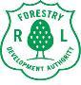

Supporting increased forest-based revenue and livelihoods for forest users and forest fringe communities in the Gola and Grebo-Krahn Landscape of Liberia (LEH GO GREEN (LET’S GO GREEN).

ANNUAL NARRATIVE PROGRESS REPORT REPORTING PERIOD:
JANUARY 1 – DECEMBER 31, 2024.
 |  | Project Locations:
Program Title: Supporting increased forest-based revenue and livelihoods for forest users and forest fringe communities in the Gola and Grebo-Krahn Landscape of Liberia. |  | (The Project is implemented in 5 counties: Grand Cape Mount, Gbarpolu, Lofa, Grand Gedeh, and River Gee) Within Liberia's North-West and South-East Landscapes.
Program Number: 01002122 |  | Lead Implementing Partner  - The Forestry Development Authority (FDA).
Participating Organization(s)
- United Nations Development Programme (UNDP).
Implementing partners
- Society for the Conservation of Nature of Liberia (SCNL), BRAC, Forestry Training Institute (FTI), Nimba Venture (NV), Green Gold (GG)
Programme/Project Cost (US$)
Total Approved Budget: US$4,943,250.00
Program Duration: 36 Months  Start Date: 01/1/2024. Original End Date: 12/2026 |  | Report Submitted By:  Davidetta Moore  Project Manager  davidetta.moore@undp.org  +231777957769  Signed:  Louis Kuukpen, UNDP-DRR/P

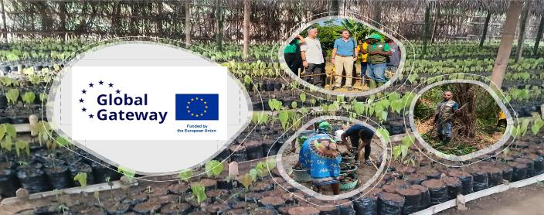

Table of Contents
ACRONYMS AND ABBREVIATIONS 3
I. EXECUTIVE SUMMARY 4
2.1 Main Purpose of the Report 5
3.1 Progress Towards Project Results (Outputs) 6
5.1 Integrated Cross-Cutting Issues 39
5.2 Key Challenges During the Period Under Review (2024) 41
5.3 Lessons Learned During the Period Under Review (2024) 42
5.4: Project Coordination & Engagement with Implementing Partners. 45
5.5 Project Coordination & Engagement with External Partners. 45
5.6 Strategic Partnerships: 47
6.1 Project Visibility and Communication 48
6.2 Gender Inclusion. 49
7.1 Annual Financial Outlook. 49
Annexes 51

Figure 1: Community level stakeholders’ consultations during CBA 7
Figure 2: CCA stakeholders community meeting in Barwu, Grand Gedeh County 10
Figure 3: Map of Koninga B RIL area 12
Figure 4: Project team photo within the Korninga B forest area 14
Figure 5: Cocoa Nursery in Gelema 16
Figure 6: Lowland Rice Plot developed in Yasalahun 19
Figure 8: Free range snail farm in Gelema 23
Figure 9: Images of cane rat at FTI facility 25
Figure 10: Charcoal briquette facility under construction at FTI 27
Figure 11: Honeybee cages deployed in Barwu Town 28
Figure 12: Photo of VSLA Group Meeting in Jebbeh Fornor 29
Figure 13: Forest based enterprises training in Ganta 31
Figure 14: carbon market training of trainers for community forest management bodies 34
Figure 15: UNV Training and Induction 39
Figure 16: Phots from 2024 project launch and inaugural board meeting 47

Table 1: Summary of Project Results (Outputs, Outcomes) for the Year Ended 2024 35

ACRONYMS AND ABBREVIATIONS

AFC | : Authorized Forest Community
CCA  CSA  CSP  CPD | : Community Conservation Agreement  : Climate Smart Agriculture  : Community Service Providers  : Country Program Document
CF | : Community Forest
FTI | : Forestry Training Institute
GAP  GAP | : Growth Accelerated Program  : Good Agriculture Practices
IPs  LGG | : Implementing Partners  : Let’s Go, Green
MOA | : Ministry of Agriculture
M&E | : Monitoring and Evaluation
NV | : Nimba Venture
PPAs | : Proposed Protected Areas
PAs | : Protected Areas
PPAs | : Proposed Protected Areas
RPA | : Responsible Party Agreement
SCNL | : Society for the Conservation of Nature of Liberia
TOT  TEI  UNV | : Training of Trainer  : Team Europe Initiative  United Nations Volunteer
UNDP  VSLA | : United Nations Development Programme  : Village Saving Loan and Association

EXECUTIVE SUMMARY

The LEH GO GREEN project (Let’s Go Green), funded by the European Union (EU) and implemented by the United Nations Development Programme (UNDP) in collaboration with the Forestry Development Authority (FDA) and other stakeholders, is a flagship initiative promoting sustainable forest governance, climate-resilient land use, and forest-based livelihoods in Liberia’s Gola and Grebo-Krahn landscapes. The project supports national climate and conservation goals while enhancing the wellbeing of forest-fringe communities who depend heavily on natural resources for their survival.

Aligned with the EU's 2021–2024 programming on forestry and conservation under the Team Europe Initiative (TEI), LEH GO GREEN contributes to Liberia’s transition toward inclusive green growth, sustainable forest management, and climate resilience. It is fully integrated with national development and climate frameworks, including the ARREST Agenda for Inclusive Development (AAID)—under Pillar 5 (Environmental Sustainability)—Liberia’s National Adaptation Plans (NAPs), and the UN Sustainable Development Cooperation Framework (UNSDCF), specifically Outcome 2, which focuses on economic diversification, food security, job creation, and climate adaptation.

Launched officially on May 15, 2024, following its signing on December 20, 2023, the project held regional launch events in Grand Gedeh (Ziah Town) and Grand Cape Mount (Fornor) counties. Throughout 2024, LEH GO GREEN transitioned from foundational planning to active implementation, delivering significant progress across nine key output areas. These achievements laid the groundwork for deeper outcome-level impacts expected in 2025–2026.

Key milestones achieved in 2024 include the preparatory engagements for four Community Conservation Agreements (CCAs) in the forest communities of Konobo, Lower Sokpo, Bondi Mandingo, and Gbeapo-Sarbo-Potupo. Additionally, the participatory cost-benefit analysis done is intended to play a central role in aligning sustainable agriculture with forest conservation incentives, paving the way for the successful negotiation and signing of the CCAs in 2025 and beyond.

To promote sustainable land use, the project mapped 400 out of 500 hectares of agroforestry plots benefiting 400 smallholder farmers across 22 communities. As of December 2024, approximately 255 smallholder farmers have received native trees and cocoa seedlings that are being transplanted across 255 hectares of degraded farmland. Each household received material and technical support to cultivate cocoa intercropped with native tree species, fruits, and vegetables. In total, 140,000 cocoa seedlings and 100,000 native tree seedlings were placed in nurseries, targeting 500 hectares of agroforestry land by end-2025. This climate-smart approach supports biodiversity restoration, reduces deforestation, and strengthens household incomes.

As part of efforts to reduce reliance on extractive forest practices, the project launched two alternative livelihood initiatives: snail farming and cane rat rearing, with three farms established in Lofa, Grand Cape Mount, and Grand Gedeh counties. Twenty-five (25) individuals, mostly women and students, were trained in managing the snail farming enterprises—advancing accessible, forest-friendly economic options.

The project also promoted community financial inclusion through the formation of 10 Village Savings and Loan Associations (VSLAs) across 30 forest-based communities, now involving 900 members, 65% of whom are women. These VSLAs provide members with opportunities to save, borrow, and invest in small-scale businesses. In parallel, 570 farmers and beekeepers, along with 30 Ministry of Agriculture staff and community service providers, received training in climate-smart agriculture, livestock management, and good agricultural practices.

In support of sustainable timber production, a pilot Reduced Impact Logging (RIL) scheme was initiated in Koningar-B Community Forest (Gbarpolu County). The scheme, backed by strong community support, aims to model low-impact, community-led timber harvesting aligned with national guidelines. While management plans are still under development, 32,635.7 hectares of forest have been identified for RIL, and governance structures and operational frameworks are being designed in collaboration with FDA and local stakeholders.

By the end of 2024, the project had disbursed USD 1,301,928.88, achieving a 73% disbursement rate and expended USD 739,729.40, reflecting a 42% expenditure rate against its annual budget of USD 1,775,709.73. The disbursement level is an indication that the project’s first year made significant progress despite the challenges that affected its inception.

Despite strong progress, the project faced several early-stage challenges. A political transition in Liberia led to delays in engaging new FDA officials. Additionally, procedural issues in certain communities necessitated adjustments in community selection. These factors extended the foundational phase and affected the timely launch of core interventions, including agroforestry plot development, community training, and procurement.

Looking ahead to 2025, the project will focus on finalizing and operationalizing the CCAs, expanding agroforestry plots to cover the remaining 245 hectares, mapping the outstanding 100 hectares. Completing the RIL pilot and establishing benefit-sharing and monitoring frameworks. These efforts will be pivotal in advancing sustainable forest management, climate mitigation, and inclusive rural development in Liberia—contributing to the global goals of biodiversity preservation, poverty reduction, and climate resilience.

2.1 Main Purpose of the Report

The main purpose of this report is to provide a comprehensive progress update on the implementation of the “LEH GO GREEN” (Let’s Go Green) project for the 2024 reporting period. It aims to present results against planned outcomes and outputs, highlight achievements and challenges, and analyze the effectiveness of activities implemented across the Gola and Grebo-Krahn forest landscapes of Liberia. The report also outlines how the project contributes to national and international development priorities, including sustainable forest governance, livelihood improvement, climate change mitigation, and inclusive rural development, while setting the stage for strategic planning and implementation in 2025.

3.1 Progress Towards Project Results (Outputs)

3.1.1 Introduction:

Under this section, the report outlines progress made toward achieving development results, marking a shift from planning to implementation and the delivery of key outputs that laid the foundation for the project’s outcomes. To ensure these results were realized, activities such as agroforestry development, cost-benefit analyses, farmer training, the formation of Village Savings and Loan Associations (VSLAs), and the piloting of Reduced Impact Logging (RIL) demonstrated advances in forest governance, livelihood diversification, and community engagement. These efforts established the institutional and participatory groundwork necessary to scale up implementation in 2025 and beyond.

Output 1.1: Conduct cost-benefit estimates to allow understanding and comparison between the benefits and loss of unsustainable activities (e.g., logging) and other sustainable land use systems (e.g., forest friendly enterprises, participation in REDD+, etc.).

Description of Expected Output:

This output aims to empower forest communities to make informed land-use decisions by providing them with clear economic comparisons between unsustainable practices such as logging and more sustainable alternatives including forest-friendly enterprises and participation in mechanisms like REDD+. This initiative was planned to allow for engagements with people at the community level to gather their perspectives and insights that could inform how the project design incentivize initiatives that could compensate for livelihood loss as a result of their engagement in conservation initiatives that seek to protect forest and biodiversity. As a key preparatory activity toward implementing Community Conservation Agreements (CCAs), this output supports both conservation and local economic development by demonstrating the potential value of ecosystem services and nature-based livelihoods.

Results Achieved: Under Output 1.1, a comprehensive cost-benefit and loss analysis was conducted in four pilot community forests Konobo, Glarro, Tonglay, and Lower Sokpo. The study, which was conducted by an independent consultant, quantified economic trade-offs between forest-conservation alternatives and unsustainable land uses. Upon the validation in 2025, the report will provide critical decision-making support for community-led forest management and CCA planning.

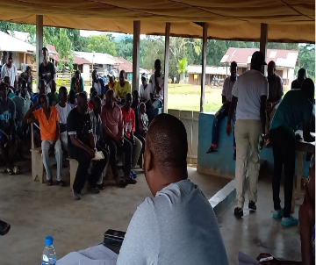
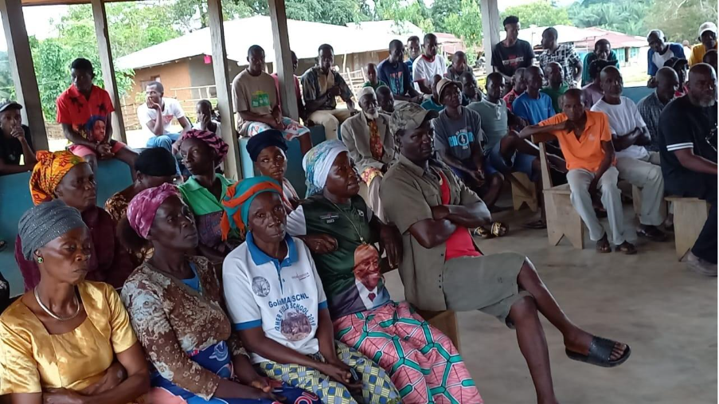

Figure 1: Community level stakeholders’ consultations during CBA

Indicator Progress:
Indicator 1.1: Cost-benefit and loss analysis report submitted (Baseline: 0, Target: 1) -Achieved 90%

Output 1.2: Establish systems (including monitoring and organizational strengthening, incentive payment scheme, incentive evaluation, etc.) for CCA in partnership with the local community, NGOs and relevant government institutions- Forestry Development Authority (FDA) and the LLA.

Description of Expected Output:
The initiative focuses on developing and implementing Community Conservation Agreements (CCAs) to support sustainable livelihoods and nature-based solutions within targeted authorized forest communities. The overarching goal is to pilot CCAs as an incentive-based model that encourages communities to adopt forest-friendly and climate-resilient practices. Through this approach, communities are empowered to establish conservation areas within their community forests and promote sustainable forestry practices that are both ecologically sound and economically viable.

To support this goal, the initiative began with preliminary community consultations to raise awareness and sensitize communities, followed by the conduct of cost-benefit analyses that compare the economic and environmental impacts of unsustainable activities such as commercial logging with those of sustainable land use systems, including forest-friendly enterprises and participation in carbon financing. These analyses were carried out using participatory methodologies in selected community forests, such as Glaro, Lower Sokpo and Konobo, to help inform the design and negotiation of CCAs. Complementing this effort, baseline forest and biodiversity inventories will be conducted in 2025 to provide a scientific foundation for conservation planning and monitoring.

Establishing the necessary institutional and technical systems is critical to the success and sustainability of CCAs. This includes developing monitoring frameworks, strengthening community organizations, and designing incentive structures such as payment schemes and evaluation mechanisms. These systems will be developed in close partnership with local communities, civil society organizations, and key government institutions, notably the Forestry Development Authority (FDA) and SCNL. A community-based monitoring framework will be introduced, including the deployment of Ecoguards led by SCNL to ensure compliance with conservation commitments outlined in the CCAs.

Once these foundational elements are in place, CCAs will be formally signed and implemented in four pilot community forests. The signing process will be preceded by a participatory planning exercise that identifies conservation milestones and assesses community livelihood needs. In exchange for making specific conservation commitments such as refraining from logging or protecting biodiversity communities will receive support in the form of agricultural inputs, alternative livelihood opportunities, training, and wages for forest patrols. This reciprocal arrangement ensures that conservation efforts are directly linked to tangible community benefits.

To ensure long-term sustainability, a CCA Sustainability Plan will be developed, including a yearly funding agreement to support implementation. The agreement and implementation plan will be validated and ratified through community-based processes, with funding allocated for a three-year period. Continuous monitoring and documentation of lessons learned from the pilot sites will be supported, with findings shared at national platforms to inform broader policy actions and potential scale-up of the CCA model across Liberia.

Results Achieved: Under Output 1.2, the project initiated critical steps toward the establishment of a national framework to guide CCA implementation. During the preliminary consultations to support the development of the CCA guide, several communities were consulted with many expressing strong interest in conserving their forests as a means of supporting climate change mitigation and ensuring sustainable benefit-sharing under the project. In parallel, conservation organizations have signaled their willingness to collaborate with both the government and local communities to advance forest conservation efforts.
In response to these developments, the Forestry Development Authority (FDA) desires to establish a structured national framework for conservation agreements. These guidelines are intended to standardize processes across pilot sites, detailing procedures for forest monitoring, benefit-sharing, conflict resolution, and institutional roles at both community and government levels.
To support this process, a consultant will be recruited in April 2025. The consultant will support the FDA in developing two strategic tools: a Community Conservation Agreement Guide and a Negotiating Guide for forest stakeholders. These tools aim to strengthen legal clarity, reduce disputes, and promote sustainable conservation practices that ensure equitable benefits for forest communities. The consultant will begin by reviewing Liberia’s legal and policy frameworks, including the National Forestry Reform Law and Community Rights Law, and analyzing international best practices to adapt relevant elements to the Liberian context. They will engage key stakeholders—such as FDA, community forest management bodies, conservation organizations, private sector actors, and traditional leaders to inform the development of the guides. The Conservation Agreement Guide will include standard clauses, rights and obligations, benefit-sharing mechanisms, and enforcement provisions. The Negotiating Guide will offer step-by-step guidance, negotiation strategies, and tools for informed decision-making. The consultant will validate both guides through stakeholder consultations, finalize them for FDA use, and present them to the FDA board. Additional responsibilities include preparing a workplan, collecting data from forest communities and agencies, and advising on how to integrate findings into conservation agreements in target landscapes.

Developing structured guidelines like the Community Conservation Agreement Guide and the Negotiating Guide can significantly strengthen community conservation efforts in Liberia. These tools provide legal clarity and standardized procedures, helping forest communities understand their rights and responsibilities in conservation agreements. By incorporating international best practices and adapting them to Liberia’s legal context, the framework promotes transparency, equitable benefit-sharing, and informed decision-making. It also empowers communities to negotiate fairly with external actors, reducing disputes and fostering trust. Ultimately, these guidelines support sustainable forest management while ensuring that conservation efforts align with community interests and national policy.

Although full systems are not yet in place, foundational work has positioned the project to meet its targets in 2025. Meanwhile, institutional strengthening has also begun at community level, including initial discussions on how incentive mechanisms such as conservation-based payments can be integrated into the CCA framework to reinforce community commitment and accountability.

Indicator Progress:
- Indicator 1.2: Number of functional CCA guidelines developed (Baseline: 0, Target: 4). Development of drafts of CCA guidelines is under development at a 50 % achievement rate.

Output 1.3: CCA signed, and implementation commences in four Pilot Community Forests

Description of Expected Output:
This output aims to formalize conservation commitments through the signing and operationalization of Community Conservation Agreements (CCAs) in four authorized community forests. The goal is to secure forest areas for conservation while aligning with community development aspirations and enabling nature-based livelihood opportunities. Through this process, forest-dependent communities gain legal recognition and structured governance systems for managing their forests sustainably, with conservation and benefit-sharing provisions embedded in each agreement.

Results Achieved: Output 1.3: While the overall target of signing four CCAs is yet to be realized, a lot of the foundational work has been done. As part of the preparatory process for the development of Community Conservation Agreements (CCAs), the LEH GO GREEN Project conducted a series of technical assessments and extensive stakeholder consultations aimed at fostering inclusive participation, informed decision-making, and community ownership. During this process, nineteen (19) forest-dependent communities were consulted, each expressing strong support and commitment to the CCA framework. These consultations were designed to be gender-responsive and broadly representative, ensuring the active participation of diverse stakeholder groups. Participants included representatives from the Forestry Development Authority (FDA), Society for the Conservation of Nature of Liberia (SCNL), local town chiefs, women leaders, youth leaders, elders, and members of Community Forest Management Bodies (CFMBs) governing authorities.

The dialogues provided a platform for stakeholders to contribute meaningfully to the design and content of the CCAs, aligning them with local priorities, cultural values, and ecological realities. This inclusive approach was critical in promoting broad-based understanding, transparency, and shared ownership, while also ensuring that the agreements reflect the aspirations and needs of all community segments, including traditionally underrepresented groups. By embedding gender equity and stakeholder diversity into the consultation process, the project has laid a strong foundation for the successful implementation and long-term sustainability of the CCAs.

The Community Conservation Agreement related pilot activities are currently being developed, with implementation planned for four pilot Community Forests (CFs): Konobo, Lower Sokpo, Bondi Mandigo, and Gbeapo, Sarbo & Potupo CFs. These community forests have undergone a thorough assessment and validation process conducted jointly by the United Nations Development Programme (UNDP), the Society for the Conservation of Nature in Liberia (SCNL), and the Forest Development Authority (FDA). This collaborative effort ensures that the selected forests are suitable for CCA support, focusing on ecological sustainability and the community’s capacity for active engagement in conservation.

As part of the preparatory work for CCA implementation, a total of 74,699.7hectares of forestland in the four CCA communities have been identified with maps verified, awaiting the CCA process operationalization. These areas are being protected in line with emerging CCA guidelines and represent a substantial advance toward meeting the project target across the four pilot forests areas. Stakeholder consultations, boundary demarcation, and interim governance arrangements were discussed during the reporting period, awaiting the finalization of national-level guidelines, which are expected to standardize and accelerate implementation in 2025.

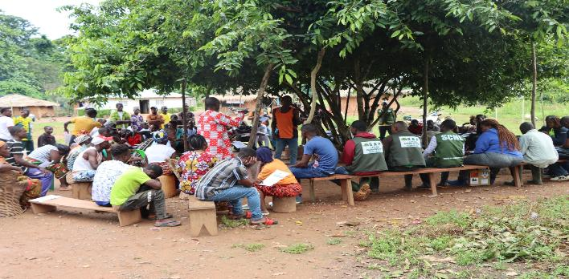

Figure 2: CCA stakeholders community meeting in Barwu, Grand Gedeh County
Indicator 1.3.1: Number of CCAs signed and implemented in pilot communities
Baseline: 0 Target: 4
Progress: Four community forests—Konobo, Lower Sokpo, Bondi Mandingo, and Gbeapo, Sarbo & Potupo located in Gbarpolu, Grand Cape Mount, River Gee, and Grand Gedeh Counties, have been identified for piloting Community Conservation Agreements (CCAs). The process to formalize and operationalize CCAs in these communities is currently underway, with an estimated achievement rate of 25%, given that one of the four steps involved has almost been completed (community engagement and CBA).

- Indicator 1.3.2: Number of hectares set aside for conservation through CCA
(Baseline 0, Target 74,699.7 hectares) Progress made: 74,699.7 hectares of land already identified and assessed for conservation with biodiversity baseline studies due in 2025. This is achieved at approximately 25% rate.

Output 2.1: A system developed to support community-based reduced impact logging in Commercial zones of community forests (mapping, inventory, environmental assessment, operational plan etc.)

Description of Expected Output:

This output focuses on laying both the technical and institutional foundation for sustainable timber extraction in authorized community forests by introducing and institutionalizing community-based Reduced Impact Logging (RIL) systems. These systems are not only designed to regulate how trees are harvested but also to ensure that logging activities align with international best practices for forest management. Key components of RIL include comprehensive forest mapping to identify tree species, growth patterns, and sensitive ecosystems; detailed resource inventories to quantify available timber and guide harvest limits; and environmental and social impact assessments to anticipate and mitigate potential negative effects on biodiversity and local livelihoods. In addition, operational planning frameworks are developed to structure the step-by-step process of harvesting, transport, and monitoring, ensuring transparency and compliance with legal standards. By embedding these practices within local forest governance structures, communities are equipped with the tools and knowledge to manage their forests responsibly, reduce waste, and avoid destructive clear-cutting practices. Ultimately, the goal is to foster a system of community-led, legally compliant, and ecologically sound timber harvesting that not only generates sustained income and employment opportunities but also safeguards the forest ecosystem for future generations. A major bottleneck that may have impeded this initiative was an outstanding concession agreement with Indo/Africa, which was terminated by the community. Thus, paving the way for engagement into the RIL initiative under the project. The Community Forest Management Body is expected to sign a resolution approving the RIL in 2025 for submission to FDA.

Results Achieved: Output 2.1: During the reporting period, foundational progress was made toward implementing Reduced Impact Logging (RIL) in the Korninga-B community forests. In September 2024, a consultant was successfully recruited to develop Sustainable Forest Management Plans (SFMPs) tailored to RIL operations. Although the final plans were not completed in 2024, several critical preparatory activities were initiated. These included a comprehensive scoping exercise to define the geographic and operational boundaries of the target forests, initial stakeholder consultations with community leaders and local forest governance bodies to ensure alignment and buy-in, and field assessments to gather baseline ecological and socio-economic data. These activities were essential for informing the structure and content of the SFMPs. The three key plans (a five-year forest management plan, a 15-year strategic forest management plan, and an annual operational plan) are expected to be completed by August 2025. Each will incorporate best practices in environmental protection, timber harvesting, and benefit-sharing. Despite initial delays in the onboarding of technical experts marked a pivotal milestone. Full implementation is expected to accelerate once draft plans are available for stakeholder review in Q3 2025.

A summary of the key activities included:
- Mapping the entire 32,635.7-hectare area to establish the spatial foundation for RIL operations.
- Engaging local governance actors to collaboratively define commercial timber zones based on ecological and regulatory criteria.

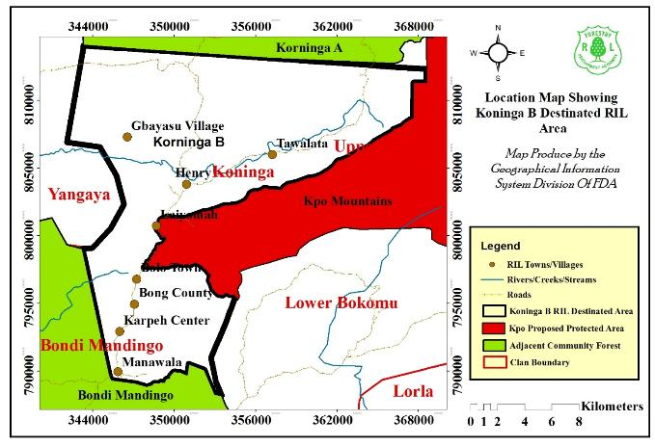

Figure 3: Map of Koninga B RIL area

Indicator Progress:
- Indicator 2.1.1: Number of Sustainable Forest-Based Management Plans Developed
(Baseline: 0, Target 1 Progress made: (Consultants hired; work initiated; 3 plans expected in 2025 thus expanding the target based on expert advice from the FDA and consultant): Current achievement rate is 0% as the plans are due for endorsement in 2025.

Output 2.2: A pilot reduced impact commercial timber extraction based on agreed national guidelines in at least one CF within the northwest landscape (Sokpo/ Konigar-B)

Description of Expected Output:
This output aims to pilot community-led Reduced Impact Logging (RIL) in a selected community forest as a demonstration model for sustainable timber extraction. The pilot is intended to operationalize national RIL guidelines within a community forest setting, allowing for real-time testing of low impact harvesting methodologies while ensuring that communities benefit equitably. Core elements of this output include the identification and delineation of forest areas suitable for RIL, the establishment of governance structures, and participatory development of operational plans.

Results Achieved: Under Output 2.2,: Under Output 2.2, substantial preparatory progress was made during the reporting period toward operationalizing the pilot Reduced Impact Logging (RIL) scheme, which is being led by the FDA with support from the UNDP. As the national authority responsible for forest governance, FDA is expected to lead the implementation of RIL activities. To support this mandate, UNDP has played a critical role in mobilizing technical and operational expertise by recruiting consultants to assist FDA in key areas of planning and execution. The FDA has designated a core team led by Mr. Abraham Sheriff, National Authorizing Officer, who serves as the Focal Point of the FDA on the RIL activity. UNDP support to FDA based on an MOU signed between the two entities involved payment for DSA of staff supporting the project and provision of logistics support to facilitate project and field level monitoring.

In the Korninga-B Community Forest, located within the northwest landscape, a total of 32,635.7 hectares, comprising of the entire forest body, were identified and mapped for inclusion under the RIL pilot. This mapping exercise, conducted by FDA with technical and logistical support from UNDP-hired consultants, represents a major milestone in establishing the spatial foundation necessary for future operational planning and implementation.

Parallel to the mapping efforts, stakeholder engagement activities were initiated in 8 communities within the Korninga-B Community Forest to build consensus and prepare governance arrangements. These included consultations with local communities, traditional authorities, and forest governance bodies. UNDP-supported consultant facilitated these engagements over a period of three months span in 2024, ensuring inclusive participation and alignment with national forest management policies.

The RIL technical working group comprising representatives from both FDA (Alvin Roberts-Senior Extension Officer, Eujay W. Zoegar-Contract Administrator) and UNDP (Davidetta Moore-Project Manager, UNDP) developed a draft RIL framework with technical input and endorsement from FDA (see annex). This framework is designed to promote community oversight, ensure compliance with sustainable logging practices, and facilitate equitable benefit-sharing. Its implementation is scheduled to begin in 2025, in tandem with the finalization of forest management plans.

Additionally, the zoning of commercial areas within the designated forest is underway. This process, supported by UNDP’s technical consultants, will delineate specific zones for RIL activities based on ecological sensitivity and commercial viability. Completion of the zoning exercise is expected to align with the broader forest management planning process during 2025.
Through its strategic support in recruiting and deploying consultants, UNDP has helped the FDA lay the groundwork for a technically sound and community-inclusive RIL pilot, setting the stage for full-scale implementation in the coming year.

Indicator Progress:
Indicator 2.2.1: Area of Community Forest Under Management Plans for Low-Impact Logging
(Baseline 0, Target 32,635.7 hectares) Progress: 32,635.7 hectares identified and under planning. This process is achieved at 40%
Indicator 2.2.2: Number of Commercial Zones of Community Forests with Established Low-Impact Logging Methodology
(Baseline 0, Target 12 Zones): Progress: In planning; zoning process ongoing but with 0% achieved.

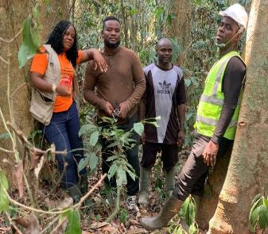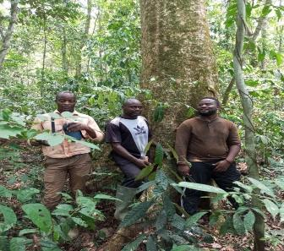
Figure 4: Project team photo within the Korninga B forest area

Output 3.1: An agroforestry scheme (forest-friendly cocoa, other crops) set up in at least 20 target communities with approximately 500 household beneficiaries from 500 ha at 1ha per household

Description of Expected Output:

This output focuses on promoting climate-resilient and forest-friendly agroforestry systems, primarily cocoa-based, across 20 targeted communities. Each participating household is expected to establish and manage one hectare of agroforestry land, resulting in a total coverage of 500 hectares. These systems are designed to provide sustainable livelihoods, reduce pressure on natural forests, and contribute to carbon sequestration over time. The output is also foundational to achieving emissions reductions and enhancing community resilience to climate change.

Results Achieved: Output 3.1: Under this output, significant progress was made toward the establishment of the agroforestry scheme, which is being implemented through a Responsible Party Agreement signed between the UNDP and the SCNL. As the designated responsible partner, SCNL is responsible for executing field-level activities, coordinating with local stakeholders, and ensuring that agroforestry interventions align with national conservation and development priorities. UNDP, in its role as the funding and oversight agency, provides strategic guidance, technical support, and fiduciary oversight to ensure the successful delivery of project outputs.

The scheme earmarked under this project entails a production system that incorporate development of cocoa and non-cocoa tree species (indigenous forest species) on the same plot along with fruit trees and vegetables. This design is intended to enhance the potential to achieve a range of benefits to the environment, climate, cocoa production, and socio-economic systems which may address deforestation, farmers’ livelihoods, and forest restoration. A total of approximately 1000 trees per ha is projected, including 800 cocoa, and 200 trees mix of fruit trees and forest trees, which amount to a target of approximately 500,000 trees over a period of 3 years

As of the reporting period, a total of 400 households across 22 communities in Grand Gedeh, Grand Cape Mount, and Lofa Counties have been actively engaged in agroforestry development activities. To further scale these agroforestry practices, SCNL, in collaboration with local communities, has successfully facilitated the propagation of 140,000 cocoa seedlings and the germination of 100,000 native tree seedlings across 10 target communities. These include Ducor Gbondo, Gondorlahun, Yassalahun, Mbaloma, and Gelema in Lofa County, and Jebbeh Fornor, Fornor, Kawalahun, Fula Camp, and Gbarjue in Grand Cape Mount County. The seedlings are currently being maintained in community-based nurseries, and distribution is ongoing for transplanting once land preparation is completed. Among these, 255 households have received 800 cocoa seedlings and 200 native tree seedlings each for transplanting under the agroforestry initiative. Each participating household is preparing 1 hectare of land each to establish integrated cocoa and native tree plantations.

The cocoa seedlings distributed are hybrid varieties from Ghana, specifically Trinitario and Forastero, known for their high yield potential and disease resistance. The native tree species include Terminalia ivorensis (Framire) and Garcinia kola (Bitter Kola), selected for their ecological value, economic potential, and compatibility with cocoa-based agroforestry systems. This initiative promotes sustainable land use by integrating cocoa with native timber and fruit trees, enhancing biodiversity, improving soil health, and providing diversified income opportunities for participating households.
. The 22 communities include:

- Grand Gedeh County: Ziah, Drouglor, Dehjaleh, Delayee, Baewu, Druwor, Bao, Tarloken, Tempo, Why-bo, Buway, Sayuo
- Grand Cape Mount County: Fornor, Jebbeh Fornor, Gbarjue, Kawalahun, Fula Camp
- Lofa County: Gondorlahun, Yassalahun, Mbaloma, Gelema, Ducor Gbondo

SCNL, with support from UNDP, has facilitated a one-day training session in each community for these households in cocoa nursery establishment and land preparation techniques. To enable effective implementation, communities received assorted tools and equipment to support nursery setup and planting activities. A detailed list of distributed tools is provided in the annex.

While the actual area under cultivation is still being established, the propagation and nursery development represent a critical preparatory milestone. These efforts are laying the groundwork for integrated agroforestry systems that combine cocoa production with native tree planting, contributing to both livelihood enhancement and ecosystem restoration.

The environmental co-benefits of these agroforestry systems, particularly in terms of carbon dioxide (CO₂) emissions avoided or reduced have not yet been quantified. However, impact assessments, including emissions reduction estimates, are planned for the final year of the project. These assessments will be based on field data collected once full implementation is achieved and the planting activities are completed.

SCNL’s role as a responsible party has been pivotal in translating UNDP’s strategic objectives into tangible community-level outcomes. Through its local presence, technical expertise, and established relationships with forest-dependent communities, SCNL has ensured that agroforestry interventions are culturally appropriate, environmentally sound, and economically viable. UNDP continues to provide oversight and support to ensure that implementation remains on track and that the project delivers measurable benefits in line with its conservation and development goals.

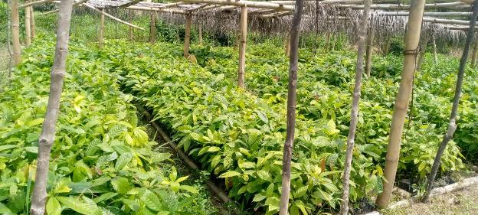
Figure 5: Cocoa Nursery in Gelema

Indicator Progress:
- Indicator 3.1.1: Number of Households Involved in Climate-Resilient Forestry and Agroforestry Practices
(Baseline 0, Target 500): Progress: 400 households activating participating in Climate-Resilient Forestry and Agroforestry Practices with achievement at 80%. As of the reporting period, 400 households are currently active; the remaining 100 are expected to join by December 2025.
- Indicator 3.1.2: Tons of CO₂ Emissions Avoided or Reduced
(Baseline 0 Target TBD) Progress: To be measured in final year. Achievement: 0%, measurement will be based on biomass growth and land-use change monitoring beginning in 2025/2026.
- Indicator 3.1.3: Number of Hectares of Cocoa-Based Agroforestry Plots Established
(Baseline 0, Target 500 ha): Progress: 140,000 cocoa seedlings and 100,000 native trees propagated | Achievement: 25%, with seedling production on track; planting and hectare coverage verification will follow nursery phase.

Cocoa Production Scheme
1. Expected Income
Each cocoa tree is expected to yield approximately 2 kg of dry, well-fermented grade 1 cocoa beans.
- Total trees: 800
- Estimated yield: 1.6 tons (1,600 kg)
- Market price: $6.20/kg
- Projected income: $9,920 USD
2. Field Layout
The plantation will be organized using a structured grid system to optimize space, growth, and shade management:
- Cocoa seedlings: Planted in a 3m x 3m grid; planting holes approx. 20 cm deep
- Native trees: Planted every 5th row in alternating cocoa rows, spaced 10m x 10m in a triangular pattern
- Land requirement: Approximately 0.73 hectares for 800 cocoa trees
3. Agroforestry Scheme Design
The scheme integrates cocoa with fruit and timber trees to enhance biodiversity, soil health, and economic resilience:
- Cocoa trees: Planted in central blocks (~800 trees)
- Fruit & timber trees: ~200 trees planted along borders and in small internal clusters
- Intercropping: Banana or plantain added for short-term income and shade

This approach supports both economic productivity and environmental sustainability, making it suitable for community-based or small-holder cocoa farming initiatives.

Output 3.2: Livelihood activities diversified to offer incentives to target communities and populations into sustainable initiatives (climate smart lowland rice, fish farming, honey)

Description of Expected Output:

This output is designed to support the diversification of forest-friendly livelihoods through the introduction and promotion of climate-smart agriculture and alternative income-generating activities. The aim is to provide tangible incentives for local populations to transition away from unsustainable land-use practices. Interventions include establishing woodlots, lowland rice farming, beekeeping, aquaculture, and other context-specific initiatives that improve income resilience while conserving forest ecosystems.

Results Achieved:
Under Output 3.2, the project made substantial progress in introducing climate-smart agricultural initiatives aimed at enhancing sustainable livelihoods and reducing environmental degradation in forest-adjacent communities. These interventions are being led by BRAC Liberia, which signed a Responsible Party Agreement with the UNDP to implement this component of the project. BRAC’s role as the responsible party has been pivotal in translating UNDP’s strategic objectives into locally grounded, high-impact activities that promote resilience, food security, and conservation. As of the end of 2024, 5 diversified livelihood initiatives have been successfully rolled out across multiple counties. These include:
- Lowland rice farming
- Vegetable cultivation
- Honey production
- Livestock rearing (goats and pigs)
- VSLA

These initiatives were selected based on community consultations, ecological suitability, and market potential. BRAC, with technical and financial support from UNDP, facilitated the design and implementation of these activities, ensuring that they are culturally appropriate, economically viable, and environmentally sustainable.

The interventions have been well-received at the community level, with early signs of success in generating alternative income sources, particularly in areas adjacent to community forests where economic options are often limited. By introducing these climate-smart practices, the project is helping to shift community behavior away from unsustainable activities such as shifting cultivation, illegal logging, and charcoal production.

In terms of land development, 2.4 hectares have been cultivated with lowland rice as part of the early-phase implementation. The lowland rice field approach adapted supports both rice and existing fish species in the ponds. This involves improving the field's structure, such as creating raised dikes and deep drainage channels or small ponds within the field, to provide refuges for the fish and ensure adequate water levels in the rice fields. While this represents a modest portion of the overall 30-hectare target for woodlot and farmland development, it marks a critical starting point. Preparatory work is actively underway to expand to an additional 30 hectares, including:

- Land demarcation and mapping
- Sourcing of agricultural inputs and tools
- Mobilization and training of farmer groups

BRAC has been instrumental in coordinating these efforts, leveraging its community networks and technical expertise to ensure smooth implementation in partnership with the Ministry of Agriculture Extension Officers at the county level. UNDP continues to provide strategic oversight, ensuring that interventions align with broader conservation and development goals.

The introduction of these livelihood initiatives is not only diversifying income streams but also aligning community incentives with forest conservation. By offering viable alternatives to environmentally harmful practices, the project is fostering a culture of sustainability and stewardship. Communities are increasingly recognizing the long-term benefits of protecting forest resources while improving household incomes.

Looking ahead, full achievement of the 30-hectare of lowland rice target is anticipated by late 2025, pending resolution of logistical challenges and land access issues. Impact assessments, including evaluations of income improvements, food security, and environmental co-benefits, are planned for the final year of the project. These will provide critical insights into the effectiveness and scalability of the interventions.

In summary, BRAC’s leadership, underpinned by its Responsible Party Agreement with UNDP, has been central to the success of Output 3.2. Through a collaborative and community-driven approach that leverages the MOA presence and expertise at the local level, the project is laying the foundation for resilient livelihoods and sustainable land use across Liberia’s forest landscapes.

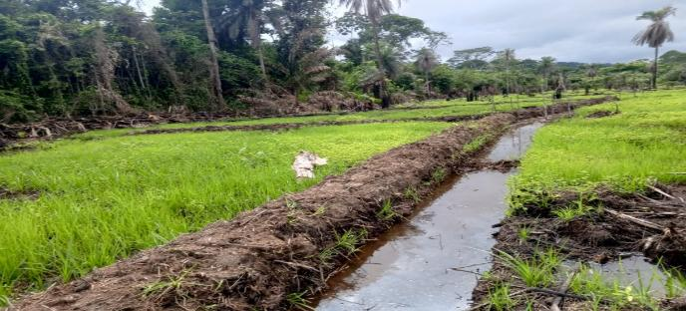
Figure 6: Lowland Rice Plot developed in Yasalahun
VSLA Scheme-Objective:
To provide a sustainable, community-managed system for saving money, accessing small loans, and receiving emergency support through a structured group-based model.
2. Group Formation
- Membership: 30 members from the same community who trust each other.
- Eligibility: Adults (18+) committed to regular saving and group participation.
- Voluntary Participation: All members join the group voluntarily.
- Validation: All members' names were validated before joining the group.
3. Governance Structure
- Elected Leadership:
  - Chairperson: Oversees meetings and ensures order.
  - Record keeper/Secretary: Records minutes, transactions, and attendance.
  - Asst. Record keeper/ Secretary: Provide support to the secretary and proxy in the absence of the secretary and support in every position.
  - Box keeper/Treasurer: Manages the cashbox and ensures its safety.
  - Money counter 1&2: They are responsible for handling and counting money, verifying the tear and counterfeit money.
  - Key Holders 1,2&3: Three members hold separate keys to the cashbox to ensure transparency.
- Bylaws and Constitution:
  - Developed and agreed upon by all members.
  - The constitution entails the governance of the VSLA and the benefits the VSLA offers to its members. Governance includes leadership structure, guidelines (rules on savings, loan amounts, interest rates, penalties, meeting frequency, etc).
4. Savings Cycle
- Duration: Typically, 9-12 months; share-out is not done below 9 months of operation.
- Share Value: Share amount is determined by the group considering the affordability of the poorest person in the group. Every member must buy at least a share in every meeting, and the highest share to be bought is five shares per week.
- Weekly Contributions: Members contribute savings during regular meetings.
6. Social Fund: Every member contributes an equal amount to the social fund. Social fund contribution is between 20%-40% of the single share value.
- Purpose: Emergency fund for health issues, funerals, or community needs. It is non-refundable.
- Contributions: Small fixed amount per meeting (e.g., 25 and above).
- Disbursement Rules: Set by the group with repayment terms or grants depending on the case.
5. Loan Management
- Loan Access:
  - Members can borrow from the group’s savings.
  - Loan limits are based on a member's total savings.
  - Maximum loan is 3 times the member’s total savings
  - Loan repayment is determined by the loan guideline stipulated in the constitution.
- Service charge/Interest Rates:
- Service charge is determined between 5–20% of the share value.
- Repayment:
  - Set period (1–3 months) with clear repayment dates.
  - Penalties apply for late payments; interest will be paid on the current amount due.

7. Record-Keeping-VSLA has two record systems.
- Passbooks and Ledgers:
  - The passbook contains individual savings/share purchase, and loans.
  - Ledger contains every member record, which includes attendance, social funds, share purchase, loan, loan repayment, fine, and cash book/financial summary.
- Transparency:
  - All transactions are conducted in the presence of members.
  - Financial updates are shared regularly.
8. Security
- Cashbox:
  - Triple-lock system with three key holders to prevent record tempering.
  - Kept in a safe location agreed upon by the group.
- Meeting Security: Held in a secure, neutral location.
9. Share-Out (End of Cycle)
- At the end of the cycle (12 months), all savings and interest earned are divided among members based on their total contributions.
- A new cycle can then begin after the share-out is conducted as agreed by the members.
- New leadership is elected at the beginning of every new circle, thereby revising the constitution
10. Training and Support
- Training on VSLA methodology and operation, which includes the seven VSLA modules.
- Module 1: Group formation
- Module 2: VSAL policy
- Module 3: VSLA constitution
- Module 4: Share purchase procedure
- Module 5: Loan disbursement
- Module 6: Loan repayment
- Module 7: Action audit and share-out

- Ongoing support by:
  - Local NGOs
  - Government extension workers
  - Community-based trainers
  - Provision of VSLA kits
11. Monitoring and Evaluation
- Regular internal evaluations to track:
  - Savings growth
  - Loan repayment rates
  - Impact on members’ livelihoods
- External reviews (if supported by a project or NGO) for accountability and learning.
12. Sustainability Measures
- Rotating leadership to prevent burnout and power concentration.
- Peer learning exchanges with other VSLAs.
- Linking mature groups with formal financial institutions for expanded services (optional).
- Business skills development training
- Provision of gender training

Snail Farming for Sustainable Livelihoods

In alignment with its strategy to diversify income sources and promote sustainable livelihoods, the Project introduced snail farming as an alternative enterprise for forest-dependent communities. This intervention was implemented by Nimba Ventures under a one-year Responsible Party Agreement with UNDP. This agreement delegated these implementing partners while keeping accountability, transparency, and results-based management in place At the end of the agreement, Nimba ventures is to established five free range snail farms, two intensive snail farms and to train fifty rural women and ten students to manage these facilities.
A major milestone was the establishment of a 14x35 ft (equivalent y to 1.3X35Msquare) intensive snail pen at Voinjama Community College, successfully stocked with 180 snails. This facility functions both as a production site and as a practical learning center for students and community members, fostering knowledge transfer and local engagement.
To expand community adoption, three additional greenhouse-style snail pens were constructed in Gelema, Kawalahun, and Ziah towns. These sites are poised for stocking and will soon enhance local access to sustainable income-generating activities.
To ensure sustainability and community ownership, 25 individuals—including 20 women and 5 students—received technical training in snail farm management. The training covered essential topics such as pen construction and sanitation, feeding practices, breeding techniques, and harvesting. The high level of female participation reflects the project’s commitment to gender inclusion and women’s economic empowerment.
This initiative contributes to biodiversity conservation by reducing reliance on bushmeat hunting and introducing a climate-resilient livelihood with strong potential for replication across other project communities.

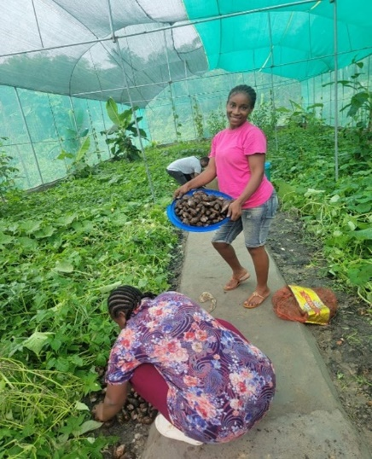
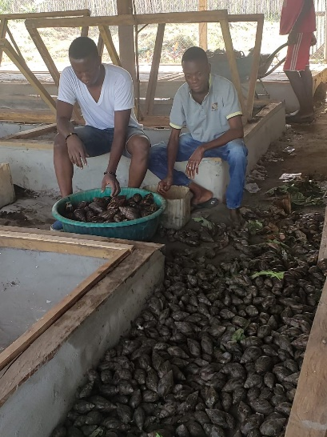
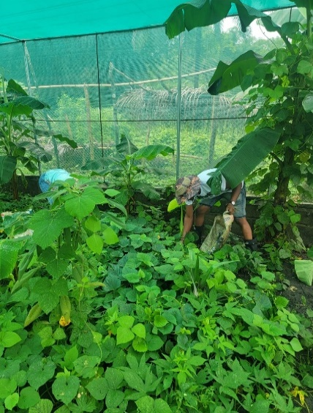
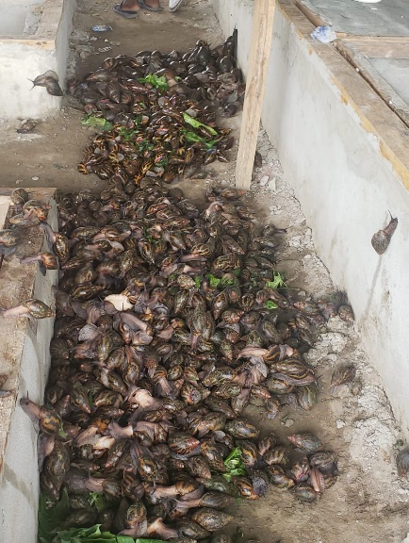

Figure : Images from selected snail farms in Gelema, Kawalahun, and Ziah towns
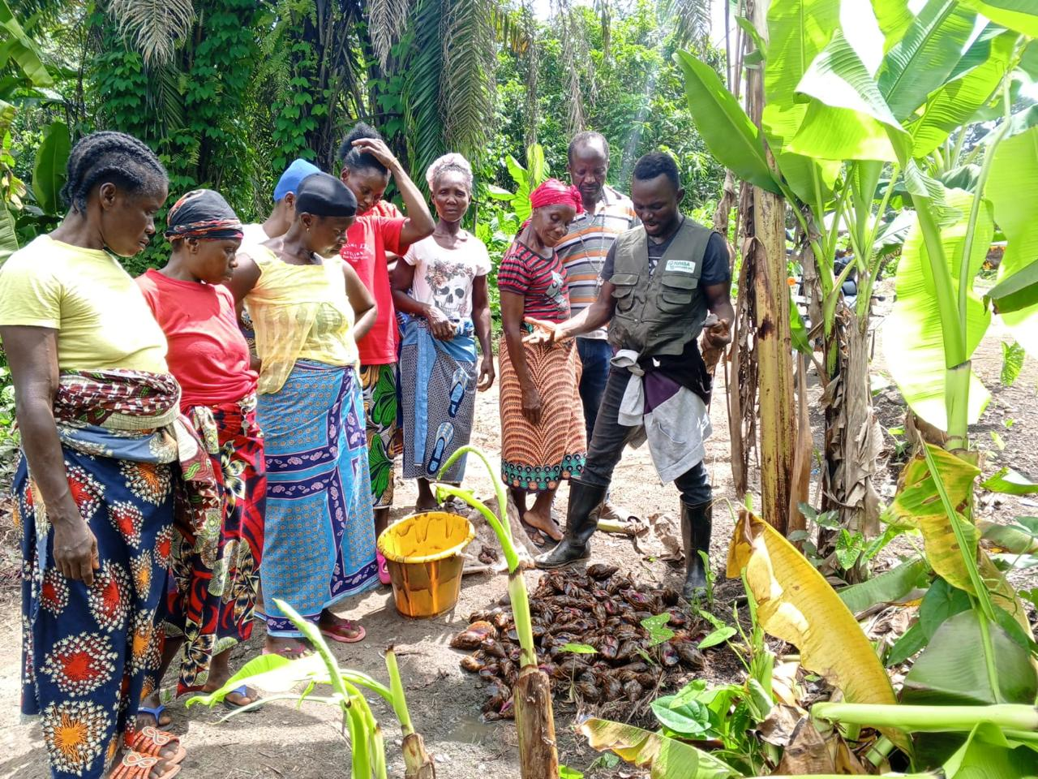
Figure 8: Free range snail farm in Gelema
Cane Rat Farming for Conservation and Livelihood Diversification
To further reduce hunting pressure on forest wildlife and provide sustainable protein and income alternatives, the project launched cane rat (grasscutter) farming in targeted locations. This component was implemented by the Forestry Training Institute (FTI) and aims to shift community reliance away from bushmeat hunting, particularly for ecologically threatened species by promoting domestication in controlled environments.
The Scheme
The scheme is a community-based cane rat farming initiative designed to ensure long-term sustainability by training staff and community members in small livestock management, building eco-friendly cages, using local feed sources (cassava, maize, elephant grass, kitchen waste), recycling waste as organic manure, and creating income through the sale of cane rats for meat, breeding, or research. Each startup involves five families, with each family receiving 4 cane rats (15 females and 5 males across all families = 20 animals total).
The communities are provided with:
- Breeding stock (initial cane rats: 4 per family)
- Training in sustainable cane rat management
- Cages and feeding strategies
- Skill transfer workshops on livestock business skills and waste management
In terms of profit,
- Each cane rat for consumption sells at USD 20.
- With 140 cane rats, communities earn about USD 2,800 per year.
- For breeding purposes, the value is higher at USD 350 per family, which increases profitability when selling stock rather than just for meat
Cane rat farming facilities were established at Lofa Community College, Zwedru Community College, and FTI Tubmanburg. These centers serve as breeding and demonstration hubs, as well as training grounds for future farmers and technicians. To date, 30 of the planned 55 cane rats have been procured and housed at the above mentioned facilities (which will be distributed to the communities subsequently), with the remaining foundation stock expected in the coming months.
A veterinarian-led Training of Trainers (ToT) program equipped five FTI staff with expertise in feeding regimes, cage design, breeding cycles, disease prevention, and humane handling practices—strengthening institutional capacity for future scaling.
In parallel, community-level training sessions are underway, targeting individuals from forest communities interested in alternative livelihoods. These training will cover both technical and business skills. On the technical side, staff and community members will be trained in sustainable cane rat management practices, which include feeding strategies using low-cost local materials (cassava, maize, grass, kitchen waste), cage construction and hygiene to prevent diseases, and waste management by recycling droppings as organic manure. On the business side, communities will receive skill transfer workshops on small livestock business management, income generation strategies, and participation in value chain activities such as processing (smoked meat) and marketing
As for follow-up on breeding, the IP sustainability plan emphasizes ongoing reproduction cycles and community capacity building. Each female cane rat will produce 7–8 pups in the first six months, with continuous reproduction expected thereafter. Communities will be guided to reinvest and expand from the initial 20 animals to approximately 140 in the first year, while also being encouraged to establish a network of cane rat farmers through peer-to-peer workshops. This network and periodic workshops will act as follow-up mechanisms to ensure breeding continues sustainably and profitability is maximized. These sessions will continue into 2025, ensuring readiness for rollout and local ownership.
Once fully operational, the cane rat farming initiative will contribute to biodiversity conservation and offer a marketable, climate-resilient livelihood, especially in regions where bushmeat remains a key source of income and nutrition.
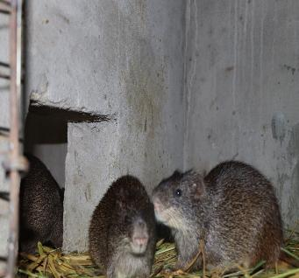
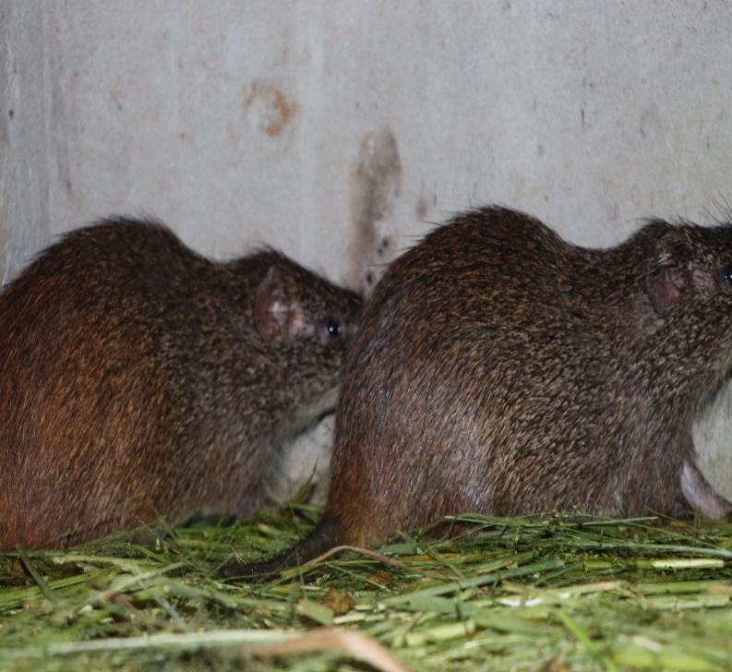

Figure 9: Images of cane rat at FTI facility
Chainsaw millers’ demobilization and charcoal production briquettes

To support the demobilization of illegal chainsaw millers and promote sustainable forest-based livelihoods, UNDP entered into a Responsible Party Agreement with Green Gold Liberia. Under this agreement, Green Gold is tasked with the procurement and deployment of charcoal briquette machines, as well as the training of charcoal millers and forest community members. This initiative also contributes to the broader strategy of transitioning chainsaw millers into alternative green enterprises.

The charcoal scheme focuses on transforming agro and forestry waste (rice husks, cassava peels, cocoa pods, etc.) into eco-friendly briquettes, reducing deforestation and promoting a circular economy. Charcoal miners are retrained as “Environmental Stewards”, shifting from cutting trees to carbonizing agro waste. Communities benefit through waste repurposing, job creation, training, and stable income. The facilities will owned by local institutions such as Lofa County University and the Forest Training Institute in Bomi. After the setting up of the equipment, Green Gold Liberia (GGL) will manage operations through contracts with custodians and former charcoal miners, ensuring sustainability. These facilities will also serve as training hubs for both students and miners, embedding management into community structures.

In terms of profit for communities, the briquette facilities are designed to tap into Liberia’s charcoal market of 360,000 tons annually (valued at $45 million USD). With briquettes priced at $100/ton, a small plant can generate about $500 per day, or $180,000 per year. This creates steady revenue streams through B2B sales to institutions such as schools, prisons, and hospitals. For communities, profitability also comes from employment, sale of carbonized waste, and participation in the briquette value chain.

Chainsaw milling, while a significant source of employment for an estimated 19,000–24,000 Liberians, is responsible for deforestation across 99,000–132,000 hectares annually. Recognizing the socio-economic complexity of the sector, the project aims to pilot community-based reduced-impact logging and introduce alternative livelihoods through charcoal production briquettes to support the demobilization and reintegration of chainsaw millers—particularly those operating near community forests linked to project sites.

During the reporting period, Green Gold Liberia initiated the procurement process for the charcoal briquette machines and commenced construction of production facilities at the Forestry Training Institute (FTI) and Lofa Community College based on fund transfer of US$150,000 provided by UNDP through the signed Responsible Party Agreement with US$18,550 for the briquette machine with production capacity of 1 ton per hour. These facilities will serve as hubs for training and production, targeting peri-urban communities such as Bopolu, Tubmanburg, and Voinjama.

Green Gold will provide support for individuals to support enterprise development in areas such as cookstove production in 2025. Training will cover both technical and business skills, ensuring sustainability and scalability. UNDP has already collaborated with Green Gold to deliver similar support, particularly for women-led energy-efficient stove initiatives.

To guide implementation, the Green Gold will leverage the Chain Saw Milling Regulation (FDA Regulation No. 115-11) and work with the Forestry Development Authority (FDA) to enhance stakeholder awareness and compliance. Additionally, the project will coordinate with the EU VPA initiative to support upstream policy dialogue and regulatory enforcement in 2025. Additionally, once the charcoal briquette machines have been set up, further activities include support to chainsaw millers to set up fast growing trees woodlots to serve as source of wood products for the briquette production.

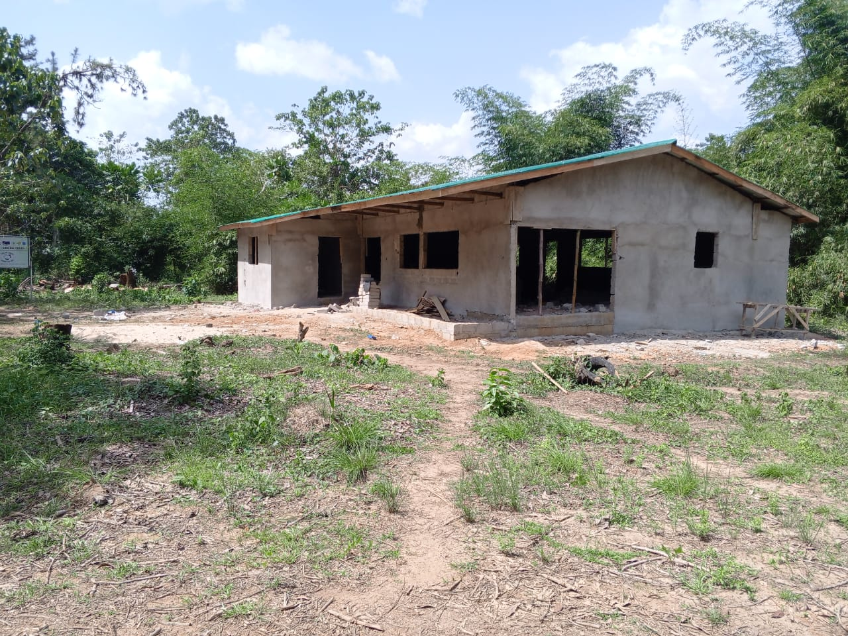
Figure 10: Charcoal briquette facility under construction at FTI
Sustainability Planning for Livelihood Interventions
All livelihood interventions under the Project, including snail farming, cane rat farming, climate-smart rice production, and Village Savings and Loan Associations (VSLA) have been earmarked for the development of comprehensive sustainability plans. These plans, to be finalized in 2025, will guide long-term community ownership, operational continuity, and scaling strategies across project sites, ensuring that the benefits of these initiatives endure beyond the project lifecycle.
Indicator Progress:
- Indicator 3.2.1: Number of Hectares of Land Developed for Woodlot and Sustainable Agriculture
(Baseline 0, Target 30 hectares): Progress: 2.4 hectares have been developed for lowland rice with an achievement at 8%.2, while additional land development is underway.
- Indicator 3.2.2: Number of Climate-Smart Agriculture Initiatives Implemented
(Baseline 0, Target 30): Progress: The project activities implemented under BRAC has so far been actively rolled out in 20 communities. These include rice farming, vegetables, livestock, and honey production, with the state of progress of implementation rated at an achievement rate of 67%.

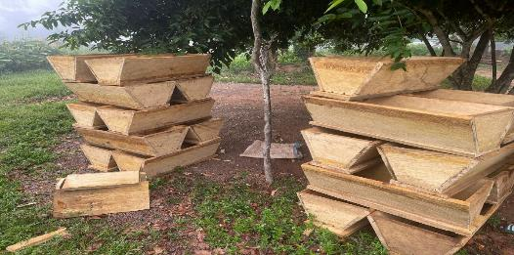

Figure 11: Honeybee cages deployed in Barwu Town
Output 4.1: Two financing models funded to support youth and women-owned forest-based enterprises (Village Savings Loan Association and Growth Accelerator)

Description of Expected Output:

This output is focused on increasing access to sustainable financing mechanisms for forest-dependent communities, especially women and youth, by implementing two complementary models: the Village Savings and Loan Associations (VSLAs) and the Growth Accelerator program. These mechanisms aim to support inclusive financial empowerment and provide capital for micro- and small-scale forest and agro-based enterprises, fostering entrepreneurship and enhancing income-generation capacity in alignment with sustainable land use.

Results Achieved: Output 4.1: In 2024, the project made significant strides in promoting inclusive economic development and sustainable livelihoods through two complementary financial models: the establishment of Village Savings and Loan Associations (VSLAs) and the rollout of the Growth Accelerator for forest-based enterprises. These interventions are laying the foundation for a locally anchored green economy in Liberia’s forest landscapes.

Village Savings and Loan Associations (VSLAs)

Ten VSLA groups were successfully established by BRAC across 30 forest-fringe communities, providing a community-managed platform for savings, microloans, and emergency support. Each group comprises 30 voluntary adult members (18+) from the same community, validated and committed to regular participation. The VSLA scheme is designed to empower marginalized populations, particularly women by enhancing financial resilience and enabling investment in small-scale enterprises and household needs.

Through this scheme, the groups operate under a structured governance system with elected leadership roles: Chairperson, Secretary, Assistant Secretary, Treasurer (Box Keeper), two Money Counters, and three Key Holders responsible for securing the triple-locked cashbox. Members collaboratively develop a constitution and bylaws, which govern savings rules, loan terms, interest rates, penalties, and leadership responsibilities.

The savings cycle spans 9–12 months, with members purchasing 1–5 shares weekly based on affordability. At the end of each cycle, a share-out is conducted, distributing savings and accrued interest proportionally. Members also contribute to a social fund of which 20 to 40% of one share’s value is used for emergencies such as health issues and funerals. This fund is non-refundable and governed by group-defined disbursement rules.

Loan management allows members to borrow up to three times their total savings, with service charges ranging from 5–20%. Repayment periods are set between 1–3 months, and penalties apply for late payments. All transactions are recorded transparently in passbooks and ledgers and conducted in the presence of members.

Training is provided through seven core modules, covering group formation, policy development, constitution drafting, savings procedures, loan disbursement and repayment, and action audits. Ongoing support is delivered by government extension workers from the Ministry of Agriculture, including District Agriculture Officer, County Agriculture Coordinator, County livestock Officer and community service providers, with VSLA kits provided to each group.

Monitoring and evaluation activities track savings growth, loan repayment rates, and livelihood impacts. Sustainability measures include rotating leadership, peer learning exchanges, optional linkages to formal financial institutions, and training in business and gender equity. As of the reporting period, 191 individuals, representing 21% of the target of 900 beneficiaries (65% women) have reported increased incomes Full target achievement is anticipated by Q4 2025 and early 2026.

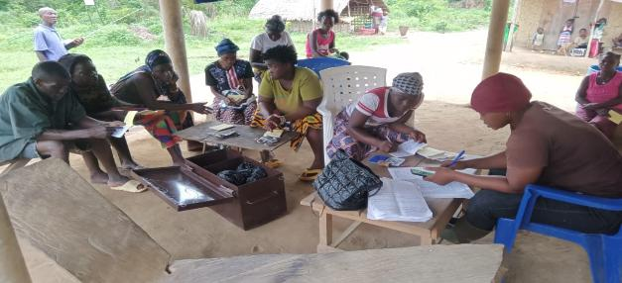
Figure 12: Photo of VSLA Group Meeting in Jebbeh Fornor
Growth Accelerator for Forest-Based Enterprises

The Growth Accelerator component, managed with the support of Accountability Lab (iCampus), has made solid progress in supporting forest-based enterprises. In 2024, ten enterprises were selected from a pool of 44 applicants across seven counties through a transparent, integrity-based process led by third-party partners and aligned with UNDP principles. The program supported these businesses to formalize by obtaining business registration and tax clearance at the very inception of the intervention. Selection criteria for the beneficiaries included eligibility, sustainability, social and economic impact, business viability, and readiness for support. Conflict interest declarations were part of the process, and full documentation, including business plans and selection reports.

The selection and approval of these enterprises were reviewed and validated by UNDP, with the list shared ahead of the first event with the EU. The budget for enterprise support was included in the 2025 Annual Work Plan (AWP), which received formal approval. Lessons from this process will inform clearer communication and documentation protocols in future engagements.

The Growth Accelerator event held in Nimba was part of the broader framework encompassing the LEHGOGREEN component. While branding overlaps may have caused confusion, steps are being taken to streamline communication and ensure accurate attribution to future events and correspondence.

Sector representation among selected enterprises reflects the economic realities of target communities, with beekeeping emerging as the dominant value chain due to its scalability and market access including supermarket distribution in Monrovia and entry into export markets. The program aims to support other sectors such as arts and crafts to scale up and optimize their potential.

The Growth Accelerator focuses on strengthening existing enterprises with proven potential. Nonetheless, efforts are underway to support and elevate other value chains such as rattan, bamboo, and arts and crafts to ensure balanced sectoral development.

Each enterprise is enrolled in a six-month bootcamp covering tailored Business Development Services (BDS), including:
- Market access strategies
- Post-harvest quality improvement
- Value addition
- Financial management
- Enterprise development

Mentorship and monitoring are ongoing throughout the training period. The funding structure allocates USD 10,000 per enterprise, inclusive of training costs. To maximize EU impact, UNDP core resources covered registration, business development, and support services, allowing the full EU contribution to be directed toward business infrastructure and expansion. Disbursement is milestone-based:
- 60% (USD 6,000) upon submission of documentation (business registration, growth plan, budget, contract)
- 40% (USD 4,000) upon verification of investments (tools, equipment, sales center construction, promotional materials), supported by receipts and delivery notes
Grant agreements and payment documentation are available in the shared folder: LGG Growth Accelerator payment documents.

EU visibility is actively promoted at the enterprise level. The EU logo and Gateway branding are featured on the program website, social media, and press releases. Each enterprise will visibly acknowledge EU support through signage, packaging, and promotional materials.

Together, the VSLA and Growth Accelerator models are driving inclusive economic transformation in Liberia’s forest landscapes. Through strategic partnerships, transparent processes, and community-driven implementation, the project is fostering financial resilience, enterprise growth, and environmental stewardship.
.
Indicator Progress:
- Indicator 4.1.1: Number of Beneficiaries with Access to Financial Services through EU Support
(Baseline 0, Target 900) (65% women)]: Progress: 191 individuals report increased income, representing 21% of targeted beneficiaries.
- Indicator 4.1.2: Number of Forest-Based Enterprises Accessing BDS and Grants via Growth Accelerator
(Baseline 0, Target 10 enterprises): Progress: 10 community based-enterprises within 20 cluster forest communities have completed business management plan training and are prepared to receive grants. Business performance monitoring will begin in 2025. This indicator has been achieved 50%.
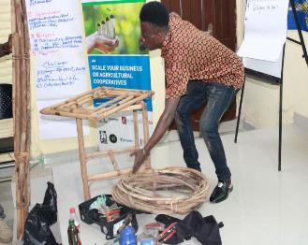
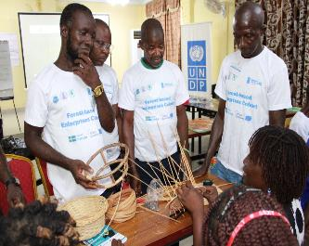
Figure 13: Forest based enterprises training in Ganta
Description of Expected Output: 4.2: Communities readiness capacity enhanced to engage and participate in carbon market dialogue; REDD+ and other payment for Ecosystem Services opportunities provided by their forests.
This output is designed to strengthen the capacity of forest-dependent communities to understand, engage in, and benefit from emerging carbon market mechanisms. Key areas of focus include public awareness, inclusive participation, particularly for women and the development of educational tools and communication materials that enable informed engagement in REDD+ and other nature-based financing mechanisms. Gender responsiveness is a central component of the training and outreach strategy.

Results Achieved: Output 4.2: Output 3.2 of the EU-funded LEHGOGREEN project, two major capacity-building trainings were conducted in 2024 to strengthen Liberia’s preparedness for engaging in carbon markets. These trainings targeted both grassroots forest governance bodies and national civil society organizations (CSOs), with a strong emphasis on gender inclusion, participatory learning, and practical application. The training was designed to build foundational knowledge, foster dialogue, and equip stakeholders with the tools necessary to support community engagement in carbon market initiatives.

Community-Based Carbon Market Training of Trainers (ToT) – Buchanan, Grand Bassa County (September 5–6, 2024)

The Training of Trainers (ToT) workshop held in Buchanan, Grand Bassa County, brought together 58 participants, evenly split between 29 women and 29 men. Participants included representatives from Community Forest Management Bodies (CFMBs), the Forestry Development Authority (FDA), Environmental Protection Agency (EPA), University of Liberia, Medica Liberia, and UNDP. The training was designed to build local capacity to engage in carbon market dialogues and equip trainers with practical knowledge to educate communities on carbon readiness.

The training covered a wide range of topics, including the impacts of climate change in Liberia, the role of forests in climate mitigation, climate financing mechanisms, and the structure and function of carbon markets. Participants were introduced to the Paris Agreement and its implications for Liberia, with particular focus on Article 6 and the country’s Nationally Determined Contributions (NDCs). The sessions emphasized the importance of sustainable forest governance and the need for inclusive, community-driven approaches to carbon market engagement.

Gender and forest governance was a central theme throughout the training. Facilitators Chrystal Angel Wardlow and Attorney Yah Porwon (Facilitator) led sessions that encouraged participants to adopt gender-sensitive approaches in forest management, highlighting the barriers women face in accessing resources and participating in decision-making. The training stressed the importance of empowering women and integrating gender perspectives into forest governance to ensure equitable outcomes.

A panel discussion featured representatives from FDA, CSOs, and the National Union of Community Forestry Development Committees (NUCFDCs), who shared insights on Liberia’s roadmap to carbon market engagement. Key milestones discussed included the completion of the Strategic Environmental and Social Assessment (SESA), the National Forest Inventory, and the establishment of Monitoring, Reporting, and Verification (MRV) systems. Participants explored the legal and institutional frameworks governing forest resources and discussed challenges such as inadequate legal structures, limited institutional capacity, and the need for fair benefit-sharing mechanisms.

To assess comprehension and reinforce learning, a written exam was administered at the end of the training. Participants who successfully completed the exam received certificates of participation, and those who passed the UNDP online carbon market course were additionally certified. The training concluded with remarks from key stakeholders, including Anthony Ohemeng-Boamah, UNDP Resident Representative, who emphasized the importance of community stewardship in managing Liberia’s carbon and forest assets. Z. Elijah Whapoe from the EPA commended the participants for their engagement and encouraged them to apply their knowledge in their respective communities. Loretta Pope Kai stressed the importance of institutional strengthening and the prioritization of women’s participation in forest governance

National CSO Carbon Market Capacity Building Workshop – Ganta, Nimba County (November 4–5, 2024)

The second training was held in Ganta, Nimba County, and convened 75 participants from civil society organizations, community groups, and government agencies. Organized by the National Civil Society Council of Liberia in partnership with UNDP, the workshop aimed to empower CSOs to engage in carbon market readiness and policy dialogue.

The training began with an overview of Liberia’s forest governance structures and challenges, establishing a foundation for understanding the complexities of carbon markets and their potential impact. Participants explored climate change mitigation strategies, the feasibility of integrating forest-based carbon credit initiatives into Liberia’s socio-economic framework, and the role of CSOs in shaping national policy.

Facilitators E. Abraham T. Tumbey Jr., Attorney Urias Goll, and Hawa Dunor Varney led sessions on climate financing, carbon market mechanisms, and gender inclusion. A panel discussion on local forest governance featured diverse voices addressing issues, challenges, and opportunities within Liberia’s road to carbon readiness. Another session focused on empowering women to participate in carbon market readiness processes, underscoring the importance of gender inclusion and equitable benefit-sharing mechanisms.

Participants engaged in interactive lectures, video presentations, group exercises, and case studies. A written exam was administered at the end of the training to evaluate participant understanding, and certificates were awarded to those who completed the assessment. The workshop served as a networking platform, fostering collaboration among stakeholders and reinforcing Liberia’s commitment to transitioning to a low-carbon economy while safeguarding the rights and livelihoods of forest-dependent communities.

The training outcomes were substantial. Participants reported a significantly improved understanding of climate change and carbon markets. Many expressed increased confidence in their ability to engage in carbon dialogues and support community-level initiatives. The inclusion of gender-responsive content and the active participation of women who made up 47% of attendees—demonstrated the project’s commitment to equitable participation. The workshop also produced a detailed post-training report summarizing findings and recommendations, which will inform future capacity-building efforts.

Visibility and Communication

To reinforce training outcomes, the project engaged a consultant to produce a video documentary on the Grebo Krahn National Park, expected by July 2025, and prepared a TOR for a second video focused on carbon readiness, REDD+, and Article 6. These materials will support community education and stakeholder engagement. Visibility efforts are currently 50% complete, with active dissemination through social media and educational platforms. EU branding is prominently featured in all materials, and enterprises supported under the Growth Accelerator are expected to visibly acknowledge EU support through signage and promotional content.

Conclusion
The carbon market and readiness trainings conducted in Buchanan and Ganta have significantly advanced Liberia’s preparedness for engaging in carbon markets. By equipping CFMBs and CSOs with the knowledge and tools needed to participate in carbon dialogues, the LEHGOGREEN project is fostering inclusive, gender-responsive, and community-driven approaches to forest conservation and climate finance. The inclusion of written exams and certification processes further strengthened the credibility and impact of the training, ensuring that participants are well-prepared to lead carbon readiness efforts in their respective communities and organizations. These trainings have laid a strong foundation for Liberia’s future engagement in carbon markets, contributing to the country’s vision of sustainable forest governance and a low-carbon future
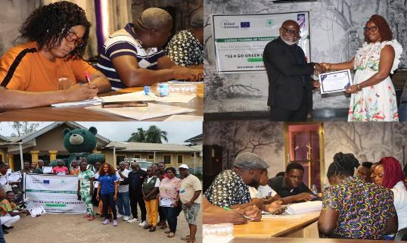

Figure 14: carbon market training of trainers for community forest management bodies
Indicator Progress:
- Indicator 4.2.2: Percentage of Women Attending Training
(Baseline 0, Target: 50%): Progress: women's participation exceeded the set target, demonstrating strong engagement of women in project learning activities with 52.3%, surpassing its target.
- Indicator 4.2.3: Number of social media Views/Accesses of the Project Documentary
(Baseline 0, Target 10,000 views): Progress: A consultant was recruited and video production initiated. Social media outreach is active, with full release expected in 2025. This is an ongoing process with 50% achieved.
Indicator 4.2.4: Incorporation of Gender-Responsive Aspects in Training and Communication Materials
(Baseline 0, Target 40% of participants are women with gender-focused content): Progress made is 100%. Gender-focused themes were embedded in training content, and 47% of participants were women, exceeding the minimum requirement.

Table 1: Summary of Project Results (Outputs, Outcomes) for the Year Ended 2024
Intervention Logic  Results Level | Objectively Verifiable Indicator | Baseline | Target | Milestone Achieved | %  Achieved | Comments
Outcome 1: Community Conservation Agreements (CCA) developed and implemented to support sustainable livelihood and nature-based solutions in targeted authorized forest | Indicator 1: Number of Community Conservation Agreements (CCAs) signed and operational in authorized forests | 0 | 4 | Not yet | 0% | The signing of the Community Conservation Agreements (CCAs) is contingent upon the development of the CCA guidelines which is expected to take place in 2025.
Output 1: Derive estimated value on community forest to allow communities compare the benefits and loss between unsustainable activities (e.g., logging) and other sustainable land | Indicator 1.1: Cost-benefit and loss analysis report | 0 | 1 | Cost-benefit and loss analysis study conducted report |  | Cost-benefit and loss analysis study conducted, report validated and submitted for approval
Output 1.2: Establish systems (including monitoring and organizational strengthening, incentive payment scheme incentive evaluation etc.) for CCA in partnership with the local community, NGOs and relevant government institutions- Forestry Development Authority (FDA) and the LLA). | Indicator 1.2: Number of functional guidelines for CCA established/strengthened. | 0 | 4 | Consultants hired to develop the guidelines | 10% | In progress-4 CFs identified; consultants hired; work initiated, guidelines are expected to be developed soon in Q-4, 2025.
Output 1.3: CCA signed, and implementation commences in four Pilot Community Forests | Indicator 1.3.1: Number of CCA signed and implemented in 4 pilot communities. | 0 | 4 | 1 in Koninga-B is ongoing | 25% | The process to pilot commercial RIL in 8forest communities delayed; however, activities have started in Koninga-B
 | Indicator:1.3.2: No of ha of forest set aside for conservation through CCA | 0 | 74,699.7 hectares | CCA guidelines have been drafted, shared for review and approvals. | 25% | 74,699.7 hectares identified and accessed and set aside
Outcome 2: Sustainable management of reduced impact community-based commercial logging promoted based on best practice and guidelines developed and piloted in targeted | Indicator 2.1: Number of community-based logging operations implementing reduced impact logging (RIL) practices in accordance with developed best practice guidelines. | 0 | 500 community-based groups trained and implemented RIL | To be determined in year 3 | TBD | The process is ongoing with community-based groups identified, trained and implemented RIL.
Output 2.1: A system developed to support community-based reduced impact logging in Commercial zones of community forests (mapping, inventory, environmental assessment, operational plan etc.) | Indicator 2.1.1: Number of Sustainable Forest- based Management plans developed. | 0 | 4 | Consultant hired; work initiated; 2 plans expected in 2025. | 0% | The process was delayed, however, consultants hired; work initiated; plans expected to be developed in Q-4, 2025.
Intervention Logic  Results Level | Objectively Verifiable Indicator | Baseline | Target | Milestone Achieved | %  Achieved | Comments
Output 2.2: A pilot reduced impact commercial timber extraction based on agreed national guidelines in at least one CF within the northwest landscape (Sokpo/ Konigar-B) | Indicator 2.2.1: Area of CF under management plans (ha) for low-impact logging | 0 | 32,635.7 hectares | 32,635.7 hectares of forest have been identified for inclusion under RIL protocols. | 40% achieved | While the management plans are still under development, 32,635.7 hectares of forest have been identified for inclusion under RIL protocols. In progress, communities engaged, governance structure drafted; implementation expected Q4-2025.
 | Indicator 2.2.2: Number of commercial zones of community forests with established low impact logging methodology. | 0 | 12 Zones | Ongoing | 0% | The process leading to determining commercial zones of community forests with low impact logging methodology is ongoing.
Outcome 3: Resilient and diversified income and livelihood opportunities and business development of forest related enterprises created and strengthened | Indicator 3: Number of climate resilient livelihood initiatives implemented in target communities and percentage of increase in income. | 0 | At least 1 set per community engaged with an average income increase of 25% | 20 initiatives ongoing | 67% | 20 climate resilient livelihood initiatives have started and ongoing.
Output 3.1: An agroforestry scheme (forest friendly cocoa, other crops) set up in at least 20 target communities with approximately 500 household beneficiaries from 500 ha at 1ha per household | Indicator 3.1.1: Number of households involved with livelihood-based climate resilient forestry and agroforestry practices | 0 | 500 | 400 are actively involved | 80% | 400 of the households are actively participating while the remaining 100 households are expected to form a part by Dec 2025
 | Indicator 3.1.2: Tonnes of CO2 emissions avoided or reduced. | 0 | TBD | To be determined in last year | 0% | Agroforestry schemes and low-impact logging foundations ongoing; CO₂ reduction impact to be measured in Year 3.
 | Indicator 3.1.3: Number of hectares of cocoa-based agroforestry plots set up | 0 | 500 hectares | 140,000 cocoa seedlings and 100,000 native trees are on nursery/germination | 25% achieved | 140,000 cocoa seedlings are put on nursery and germination of 100,000 native tree seedlings in 10 communities.
Output 3.2: Livelihood activities diversified to offer incentives to target communities and populations into sustainable initiatives (climate smart lowland rice, fish farming, honey | Indicator 3.2.1: Number of land (ha) developed for woodlot. | 0 | TBD | Not yet | 0% | the woodlot development is planned to be undertaken subsequently so that it is linked to the charcoal briquette plant under construction by GGL
 | Indicator 3.2.2: Number of Initiatives of climate smart agriculture implemented | 0 | 30 | 20 initiatives ongoing in different communities | 67% | 20 initiatives ongoing
Outcome 4: Mechanisms to foster sustainable financing of local forest-based enterprises promoted for enhancing capacity of forest communities to be aware of carbon market | Indicator 4.1: Number of Mechanisms put in place to foster sustainable financing of local forest-based enterprises promoted for enhancing capacity of forest communities to be aware of carbon market opportunities to participate in carbon readiness activities. | 0 | 1 | Not yet | 0% | The process delayed; however, it is expected to in last quarter of 2025.
Output 4.1: Two financing models funded to support youth and women owned forest-based enterprise (Village Savings Loan Association and Growth Accelerator) | Indicator 4.1.1: Number of beneficiaries with access to financial services with EU support: a) firms b) Individuals | 0 | 900(65% of whom are women) | 191 have increased their incomes | 21% | 10 VSLAs groups in 30 forest-based communities established with ongoing activities.
 | Indicator 4.1.2: Number of agriculture and forest-based enterprises/beneficiaries having access to business development training and grants through the Growth Accelerator with increase in business revenue/new income created. | 0 | 10 | 10 forest and agro-based enterprises established | 50% | 10 forest and agro-forest based enterprises established, beneficiaries selected, trained, ready to receive grants.
Output 4.2: Communities’ readiness capacity enhanced to engage and participate in carbon market dialogue | Indicator 4.2.2: % of women attending the training | 0 | 50% | More than 52.3% women participation achieved | 100% | More than 52.3% of women are participating.
 | Indicator 4.2.3: Number of social media views/access of video documentary | 0 | 10,000 | Project visibility ongoing on social media, while materials for video documentary developed, pending distribution. | 50% | Consultant engaged; first video in production ongoing.
 | Indicator 4.2.4: Incorporation of gender responsive aspects in awareness, communication, and educational materials | 0 | 40% of training participants are women Presence of gender responsive aspects in the training. | 47% | 100% | 47% of training participants are women presence of gender responsive training.

5.1 Integrated Cross-Cutting Issues

This project employs a comprehensive approach to sustainable forest management and rural livelihood enhancement by integrating critical cross-cutting themes: gender equality, youth empowerment, climate change mitigation and adaptation, inclusive governance, and capacity development. This ensures outcomes that are environmentally sustainable, socially inclusive, economically empowering, and resilient to climate challenges.
Gender Equality and Women’s Empowerment are central to social inclusion. The project supports women’s participation in economic and governance processes, engaging 191 women through Village Savings and Loan Associations (VSLAs) in different communities. Training enables women to transition from harmful activities like the bushmeat trade to alternative livelihoods such as vegetable gardening and snail farming. Women’s representation in Community Forest Management Bodies (CFMBs) promotes gender-responsive forest governance. However, only 17% of agroforestry participants are women, highlighting ongoing barriers and the need for enhanced outreach and incentives.
Youth Engagement and Employment: To strengthen capacity building and ensure the long-term success of the project, sixteen community volunteers were thoughtfully selected and recruited with initial 1-year contracts. These volunteers are tasked with supporting project monitoring for the Community Conservation Agreements and laying a sustainable foundation at the community level for all project activities. To fully prepare them for their roles, they participated in an intensive one-day training and induction program at UNDP’s office prior to their deployment in August 2024. This comprehensive orientation provided the essential knowledge, skills, and resources needed to become effective and engaged members of the team, while also aligning them with the organization’s mission and values.

The training program covered the project’s work plan, introduced key donors and implementation partners, and included specialized capacity-building sessions on extension services to be delivered within the communities. Drawing on their educational backgrounds from institutions like the University of Liberia, the Forestry Training Institute, and local community colleges, volunteers were equipped with practical expertise. Youth participants, in particular, received instruction in climate-smart agriculture, nursery management, and agroforestry, enhancing their employability and entrepreneurial potential. Furthermore, emerging opportunities in sustainable charcoal production and carbon markets are aligning youth employment with the expanding green economy, driving both socio-economic resilience and environmental stewardship.
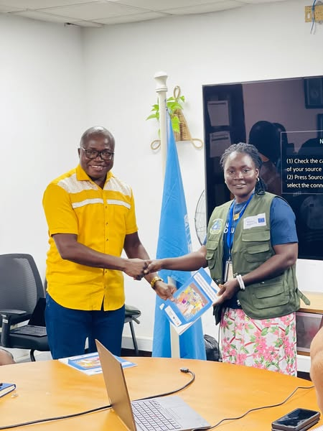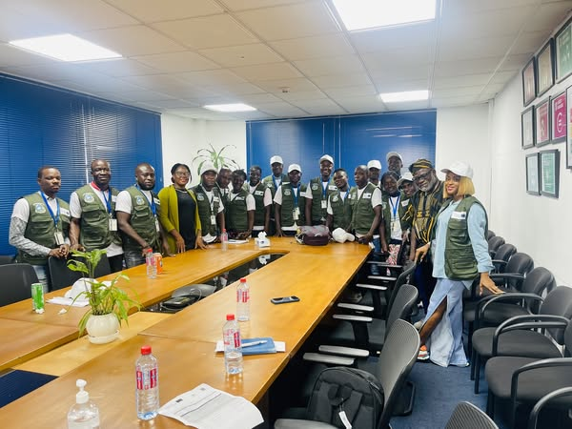
Figure 15: UNV Training and Induction
Climate Change Mitigation and Adaptation form the project’s environmental foundation, aligned with national and international frameworks including the Paris Agreement and REDD+. The establishment of 500 hectares of agroforestry plantations (around half a million trees) enhances carbon sequestration and ecosystem restoration. Sustainable practices like low-impact logging and biochar use reduce forest degradation and dependence on unsustainable charcoal. Over 300 farmers have received climate-smart agriculture training to adapt to erratic weather and improve food security.
Inclusive Governance and Community Rights underpin sustainable resource management. Formalizing community forests in key areas strengthens tenure security and empowers local leadership through legally recognized CFMBs, facilitating participatory decision-making and equitable benefit-sharing. Training in carbon rights and transparent governance reinforces community ownership and balances ecological sustainability with social justice.
Capacity Building and Knowledge Transfer for Institutional Sustainability

In 2024, the LEH GO GREEN Project made significant strides in strengthening institutional capacity and promoting knowledge transfer among key government partners and United Nations Volunteers. These efforts were central to the project’s strategy for ensuring long-term sustainability, effective service delivery, and community ownership of conservation and livelihood initiatives.

Empowering Government Partners and Community Service Providers: To reinforce institutional foundations and enhance technical competencies under the project, a two-day training was conducted in Gbarnga City Bong County to 20 technical staff from the Ministry of Agriculture (MoA) and 10 Community Service Providers (CSPs) recruited by BRAC from within the project communities. The training covered critical thematic areas, including Climate-Smart Agriculture (CSA), Good Agricultural Practices (GAP), and basic livestock management. Participants were equipped with practical skills and knowledge to support smallholder farmers in adopting environmentally sound and resilient farming techniques. CSA modules emphasized soil health improvement, agroforestry integration, water conservation, and climate risk reduction. GAP sessions focused on pest management, post-harvest handling, and safe use of agro-inputs, while the livestock component addressed small ruminant care, feed management, and animal health using low-cost, community-appropriate methods.

The training approach combined classroom instruction with field-based demonstrations, peer learning, and problem-solving exercises, enabling participants to contextualize technical knowledge within the realities of rural communities. This hands-on methodology has proven effective in enhancing the likelihood of knowledge application and transfer in ongoing extension work.

By investing in the skills of public sector staff and frontline service providers, the project is helping to institutionalize sustainable agricultural practices, promote consistent farmer support, and build the human resource base necessary to sustain project outcomes beyond its lifecycle. Additionally, these efforts have fostered inter-agency collaboration, contributing to a more coordinated and responsive approach to rural development and environmental stewardship.

Volunteer Induction for Community-Based Forest Governance: To achieve the outcomes of the Project, fifteen community volunteers (UNVs) were strategically recruited on August 1, 2024, based on their educational qualifications and their origin from the target communities, ensuring both competence and local relevance. Complementing the government-focused capacity development, the 15 United Nations Volunteers were inducted to serve as Project Associates across target communities in Lofa, Grand Cape Mount, Grand Gedeh, Gbarpolu, and River Gee Counties. These volunteers play a pivotal role in advancing community-based forest governance and supporting sustainable livelihood interventions.

The volunteers are actively engaged in monitoring the implementation of Community Conservation Agreements (CCAs), facilitating compliance, and strengthening community engagement. Their presence at the grassroots level helps to lay the groundwork for long-term sustainability of project interventions, acting as vital liaison between the project team and local stakeholders.

This initiative reflects the project’s commitment to local ownership, inclusive participation, and grassroots leadership in environmental conservation and rural development. Through their work, the volunteers are contributing to the empowerment of forest-dependent communities and reinforcing the project’s broader goals of combating deforestation and promoting sustainable land-use practices.
United Nations Volunteers
Monthly allowance
The monthly living allowance provided to United Community Volunteers differs depending on the location where they are assigned. The table below shows each location along with the corresponding allowance amount.
NO | COUNTY | AMOUNT
1. | Grand Gedeh County | 823.26
2. | Grand Cape Mount County | 823.26
3. | Gbarpolu County | 823.26
4. | River Gee County | 823.26
5. | Lofa | 688.78

As for the National Volunteer, the amount is 1,885.07 per month.

Hiring process
The recruitment of volunteers was carried out by the United Nations Volunteers (UNV) Programme Office. A call for applications was published in May 2024, and once the application period closed, a desk review was conducted to shortlist qualified candidates who were subsequently notified. Contracts were issued with an official start date of August 1, 2024. It is important to note that all volunteers received a resettlement allowance at the beginning of their contracts (see breakdown below).
NO | COUNTY | AMOUNT
1. | Grand Gedeh County | 1,417.98
2. | Grand Cape Mount County | 1,417.98
3. | Gbarpolu County | 1,417.98
4. | River Gee County | 1,417.98
5. | Lofa | 1,288.93

5.2 Key Challenges During the Period Under Review (2024)

During the period under review, the following were some of the key challenges experienced:
- Poor Road and Transport Infrastructure: Inaccessible roads and challenging terrain, especially during the rainy season, delayed implementation and hindered access to remote forest communities.
- Delayed Procurement and Mobilization of Consultants: The hiring and mobilization of technical consultants for critical studies such as the Cost-Benefit Analysis (CBA) and Reduced Impact Logging (RIL) were significantly delayed. It was difficult attracting potential consultants and candidates that necessitated readvertising consultancy.
- Legal Disputes and Community Forest Conflicts: Ongoing legal and land tenure disputes in some target sites (e.g., Tonglay and Glaro Community Forests) disrupted and delayed planned activities and community engagement to support the CCA planning process, which required detailed community consultations, including sensitization and awareness.
- Timing Misalignments Between Studies and Implementation Activities-Delays in finalizing the CBA and RIL studies affected the alignment of these findings with downstream activities such as the signing of Community Conservation Agreements (CCAs) and agroforestry roll-out.
- Budget Execution Challenges: While implementation was ongoing, some components experienced slow disbursement, leading to an unspent budget balance of $473,780.85 by the end of 2024.
- Project Site Adjustments Due to External Constraints-The project was forced to replace key pilot sites (e.g., Tonglay and Glaro) due to external and unforeseen complications, requiring logistical and planning realignments.
- Seasonal Constraints Impacting Field Activities-Heavy rainfall during peak periods restricted field movements and delayed scheduled planting, training, and infrastructure development.
- Glaro Proposed Community Forest-Tensions emerged due to disputes over boundary demarcations, with some areas excluded from the defined forest boundaries. This issue was compounded by confusion within the community regarding the Forestry Development Authority's (FDA) role in recent legal matters, further intensifying friction. To resolve these challenges, the Glaro Community proposed forest, initially validated as a potential area for the CCA, was replaced with Gbeapo, Potupo & Sarbo, an Authorized Community Forest with clear legal status and readiness for conservation efforts. This adjustment ensures alignment with the project’s objectives of sustainable community engagement and effective conservation while addressing socio-political concerns. By selecting Gbeapo, Potupo & Sarbo authorized community forests for the conservation agreement implementation, the project avoids potential delays and ensures smooth implementation, fosters better collaboration with communities, and reinforces commitment to conservation goals.

5.3 Lessons Learned During the Period Under Review (2024)

Implementing forestry and climate-resilient land use projects in Liberia’s remote forest regions poses distinct logistical, cultural, and institutional challenges. These lessons and adaptive strategies reflect how the LEH GO GREEN project responded to evolving field realities during 2024.

🔹The Importance of Feasibility and Strategic Planning Before Implementation
A key lesson emerging from the LEH GO GREEN Project is the importance of conducting rigorous assessments and consultations prior to initiating any community-based livelihood activity or procuring related equipment, such as for briquette production, cane rat rearing, or snail farming. These assessments are essential to ensure that interventions are cost-effective, sustainable, and tailored to local socio-economic and ecological contexts. In response to early implementation challenges, UNDP proactively extracted lessons learned from evidence-based studies to inform future planning and decision-making. This strategic shift toward a results-oriented, data-driven approach has significantly enhanced the project’s ability to allocate resources efficiently, reduce implementation risks, and increase the likelihood of long-term impact. To further strengthen project adaptability, expert-level consultations were integrated into the planning and review processes. These engagements brought together technical specialists, sectoral experts, and local practitioners to provide insights on feasibility, scalability, and community relevance. Their contributions have been instrumental in refining intervention designs, aligning them with best practices, and ensuring responsiveness to emerging challenges. By embedding evidence-based planning and expert consultation into its operational framework, the project reinforces its commitment to accountability, adaptive management, and sustainable development outcomes—laying a strong foundation for replicable and resilient livelihood models across forest-dependent communities.

🔹 Local Knowledge and Community-Based Engagement is Critical Lesson Learned:
Forest communities possess detailed knowledge of their landscapes, seasonal access points, and cultural dynamics. Engaging them early and continuously enhances trust, ownership, and smoother implementation.

Adaptation Strategy:
- The project partnered with local Community-Based Organizations (CBOs) familiar with terrain and logistics.
- Engaged community leaders to disseminate messages and mobilize participation in inaccessible areas.
- Embedded field staff within communities to ensure sustained presence and quick problem resolution.
🔹 Infrastructure Planning Must Be Seasonally and Contextually Informed Lesson Learned -
Seasonal Road inaccessibility during Liberia’s rainy season severely delayed field operations.
Adaptation Strategy:
- Adjusted field calendars to avoid peak rainy periods.
- Pre-positioned materials and scheduled planting, training, and infrastructure development during dry seasons.
- Utilized local transport knowledge to access communities via alternate routes.

🔹 Early Consultant Procurement Prevents Downstream Delays
Lesson Learned:
Delays in hiring consultants for critical studies (e.g., CBA and RIL) affected the project timeline and field alignment.
Adaptation Strategy:
- Revised procurement procedures to streamline TOR approval and recruitment.
- Initiated preparatory studies earlier in the planning cycle to align findings with implementation milestones.

🔹 Legal Readiness and Land Tenure Clarity Are Prerequisites-
Lesson Learned:
Legal disputes and unclear tenure status (e.g., in Tonglay and Glaro) created significant roadblocks.
Adaptation Strategy:
- Replaced affected sites with alternative communities (e.g., Bondi Mandingo, Gbeapo, Potupo & Sarbo) that met tenure and legal readiness criteria.
- Strengthened legal screening and vetting protocols prior to site selection.

🔹 Continuous Community Engagement Overcomes Cultural Barriers
Lesson Learned:
Irregular engagement leads to misunderstandings and resistance due to cultural norms and traditional land use practices.
Adaptation Strategy:
- Maintained ongoing dialogue with traditional leaders and youth/women’s groups.
- Leveraged respected community intermediaries for information dissemination and conflict resolution.

🔹 Documentation and Knowledge Sharing Improve Learning and Accountability
Lesson Learned:

Systematic documentation of implementation insights helps refining approaches and improve stakeholder transparency. Throughout the LEH GO GREEN Project, technical staff from implementing partners, including the Forestry Development Authority (FDA), actively contributed to the identification and analysis of operational challenges and successes. These reviews facilitated the structured sharing of lessons learned, enabling adaptive management and continuous improvement of project interventions. By embedding this reflective practice into the implementation cycle, the project has strengthened its responsiveness to field realities, improved coordination among stakeholders, and reinforced accountability across all levels of engagement.

Adaptation Strategy:
- Regularly updated stakeholders through community briefings, validation workshops, and shared reports.
- Institutionalized learning sessions for project teams to incorporate field feedback.

🔹 Flexible Financial Planning Enables Rapid Response to Field Realities
Lesson Learned:
Disbursement delays and budget absorption issues highlight the need for nimble financial planning.
Adaptation Strategy:
- Maintained a flexible budget structure to shift resources between components when delays occurred.
- Prioritized low-cost, high-impact interventions during periods of reduced field access.

🔹 Backup Site Planning Ensures Continuity Amid Disruption
Lesson Learned:
When unforeseen legal or social issues arise, having pre-approved alternate sites can sustain project momentum.
Adaptation Strategy:
- Identified and assessed alternative community forests as contingency options.
- Integrated flexibility into implementation plans to allow swift transition to new sites when necessary.
Aligning Studies with Implementation Improves Cohesion
Lesson Learned:
The disconnect between the timing of technical studies and field-level interventions weakened coordination.
Adaptation Strategy:
- Updated work plans to ensure that critical assessments (CBA, RIL) are finalized well ahead of CCA signing and livelihood deployment.
- Integrated technical and field teams for improved cross-component coordination.

5.4: Project Coordination & Engagement with Implementing Partners.

The project’s main implementing partners include the Society for the Conservation of Nature of Liberia (SCNL), BRAC, Forestry Training Institution (FTI), Nimba Venture (NV), and Green Gold (GG). In collaboration with the United Nations Development Programme (UNDP) and the Forestry Development Authority (FDA). The FDA and UNDP consummated a Memorandum of Understanding under which the FDA is leading project oversight and coordination with other implementing partners. These partners hold quarterly technical steering committee meetings to review and guide project implementation. These meetings have proven instrumental in accelerating the delivery of project activities, particularly in hard-to-reach communities.

Implementing Partners now operate on a unified reporting template, which has streamlined communication and coordination. Moreover, partners actively participate in project planning meetings, where UNDP provides feedback and strategic direction. This collaborative working relationship has significantly enhanced the rate of project deliverables. For example, under Outcomes 2 and 3, UNDP, SCNL, and other project partners have successfully aligned their activities to complement each other. Strong coordination among partners has also facilitated efficient information dissemination, community engagement, and stakeholder consultations.

To ensure the project stays on track, the donor (EU), UNDP, FDA, SCNL, BRAC, and other key stakeholders conduct regular field monitoring visits. These visits not only assess the progress of project activities but also provide timely feedback to address any issues. For instance, in December 2024, a delegation from the European Union, along with the LEH GO GREEN team and representatives from BRAC and SCNL, visited a project site in Grand Cape Mount County. During this visit, project beneficiaries showcased their efforts in forest conservation, sustainable land use practices, and the monitoring of communities around the protected areas (PAs) and proposed protected areas (PPAs). The communities engaged in these monitoring efforts include: Fornoh, Jebbeh Fornoh, and the FTI head office-intensive cane rat pilot center. Monitoring of Protected Areas (PAs) and Proposed Protected Areas (PPAs) is directly linked to the achievement of the LEH GO GREEN Project’s outcomes, by tracking behavior change of those surrounding the forest. These visits not only assess the implementation status but also provide timely, actionable feedback to address emerging challenges. This engagement reinforces the project’s emphasis on participatory governance and adaptive management, ensuring that conservation efforts are both community-driven and results-oriented.

5.5 Project Coordination & Engagement with External Partners.
Throughout the first year, the project’s external partners actively took part in various coordination meetings to enhance collaboration and ensure the effective implementation of the project’s shared goals. These engagements helped knowledge sharing, strategic decision-making, and alignment on key initiatives.
One of the key coordination mechanisms was the Technical Steering Committee (TSC) meetings. These sessions provided a platform for partners to engage in in-depth discussions on programmatic strategies, emerging challenges, and opportunities for improvement. By contributing technical ability, sharing best practices, and collaboratively developing action plans, the TSC meetings strengthened the overall effectiveness of our collective efforts.
Additionally, partners played a crucial role in the project’s Board Meeting, where strategic guidance and governance decisions were made. These meetings allowed stakeholders to review progress, assess risks, and provide recommendations on operational priorities. The active participation of partners ensured transparency, accountability, and alignment with organizational goals. In summary, the Board deferred approval of the 2025 Annual Work Plan pending FDA’s review, which was subsequently reviewed and endorsed by the FDA. UNDP was tasked with supporting FDA on conservation agreements, submitting quarterly technical reports to the EU, and coordinating regular technical meetings with implementing partners. All partners were directed to develop sustainability plans and outline economic benefits of activities.
During the period under review, the LEH GO GREEN Project maintained a strong network of resolute partners to enhance the effectiveness, transparency, and sustainability of its interventions. This was achieved through structured engagement platforms, joint planning processes, technical collaboration, and knowledge sharing.
As part of this effort, the project convened and participated in a range of collaborative activities with key institutional/organizational and civil society stakeholders, including Technical Steering Committee Meetings, Joint Monitoring Missions, Capacity-Building Workshops and Learning Exchanges. These platforms provided opportunities to align priorities, review project progress, address implementation challenges, and strengthen partner capacities.
Key Partners Engaged:
- Forestry Development Authority (FDA): Provided technical oversight and regulatory guidance on community forest management, Reduced Impact Logging (RIL), and Community Conservation Agreements (CCAs).
- Ministry of Agriculture (MOA): Supported climate-smart agriculture (CSA), agroforestry initiatives, and technical training for extension officers and community service providers.
- Environmental Protection Agency (EPA): Ensured that project interventions aligned with national environmental standards and climate policy frameworks.
- Ministry of Gender (MoGCSP): Collaborated on gender mainstreaming efforts and provided policy direction on inclusive project design and implementation.
- Food and Agriculture Organization (FAO): Provided technical assistance and knowledge exchange on sustainable land use, forest governance, and food security interventions.
- Wild Chimpanzee Foundation (WCF): Partnered in biodiversity protection efforts and co-managed monitoring in forest landscapes with ecological importance.
- Royal Society for the Protection of Birds (RSPB): Shared expertise on forest conservation financing and community-based forest management systems.
- National Union of Community Forestry Management Bodies (NU-CFMB): Facilitated grassroots coordination and provided feedback loops between the project and community forest governance institutions.
- National Union of Community Forestry Development Committees (NU-CFDCs): Supported community-level consultations, dispute resolution, and promoted equitable benefit-sharing mechanisms.

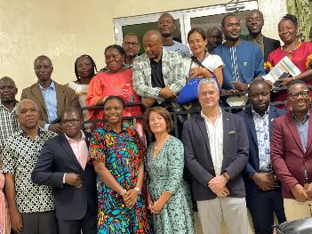
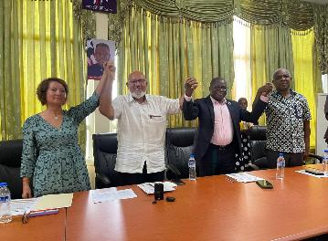

Figure 16: Phots from 2024 project launch and inaugural board meeting

5.6 Strategic Partnerships:

As the lead implementing partner of the LEH GO GREEN Project, the Forestry Development Authority (FDA) has played a pivotal role in driving strategic coordination, ensuring effective execution, and fostering strong multi-stakeholder partnerships. In line with its commitment to operational leadership, the FDA formally designated Mr. Alvin Roberts as the project’s focal person on August 20, 2024. His mandate includes overseeing collaboration efforts and streamlining communication between implementing partners and the project team.

To support the FDA focal person in fulfilling his responsibilities, the project provided essential equipment, including a laptop, monitor, keyboard, and accessories, and logistical support for field-level monitoring. In accordance with UNDP DSA guidelines, the focal person and other FDA field staff receive a Daily Subsistence Allowance (DSA) of USD 70 per night for all official field travel for monitoring and community training activities conducted in 2024. The focal person’s involvement has been instrumental in facilitating timely decision-making, proactively addressing implementation challenges, and maintaining alignment among stakeholders. Under his coordination, the FDA strengthened inter-agency engagement by convening technical steering committee meetings with key institutions such as the Ministry of Agriculture (MoA), REDD+, Ministry of Gender, UNDP, and the Environmental Protection Agency (EPA). These meetings established a structured platform for joint decision-making, knowledge exchange, and cross-sectoral coordination—enabling alignment of institutional priorities, optimized resource allocation, and a unified approach to sustainable conservation and development.

Beyond its coordination role, the FDA has been central to advancing inclusive development and gender equality. Through collaboration with UNDP, the FDA has supported scalable models that promote gender-responsive conservation and livelihood strategies. Notably, under the EU-supported LEH GO GREEN Project, the FDA facilitated the active participation of women in forest conservation. Women-led groups received training in sustainable livelihoods such as cocoa farming and nursery establishment, along with tools and resources to support income generation. These efforts have empowered women economically and ensured that conservation initiatives remain inclusive, community-driven, and sustainable.

6.1 Project Visibility and Communication

To ensure the visibility and effective communication of project activities and achievements, the “LEH GO GREEN” project developed a comprehensive communications and visibility plan. This roadmap ensures that key stakeholders and the public are informed about the project’s progress and impact. Key visibility efforts include:
- Media Coverage: The project has been featured seven times in local daily newspapers and four times on radio programs. These media engagements highlighted the project’s launch, ongoing activities, and notable achievements.
- Social media: The project has maintained an active presence on UNDP’s social media platforms, including Instagram, Facebook, and X. By tagging partners and showcasing activities, the project generated significant interactions, reaching over 2,000 viewers on these platforms.
- Training for Implementing Partners: The communications specialist conducted training sessions for implementing partners (IPs) on branding and visibility. These sessions ensured that IPs’ strategies align with donor branding guidelines and effectively communicate project milestones.
- Online News and Publications: Project activities and achievements have been published on widely read platforms, including the UNDP website, implementing partner websites, and newsletters.
- Community Engagement: Local community members have been actively engaged and sensitized about the project. Visible symbols such as signage, signboards at tree planting sites, and project fact sheets have been distributed to approximately 5,000 beneficiaries, enhancing awareness and ownership.
- School Partnerships: The project has collaborated with schools to establish LGG Nature Clubs. These clubs aim to promote environmental education and encourage student participation in conservation efforts.
- Tangible Outcomes: Activities such as tree planting, deployment of project associates/UN Volunteers, Community Conservation Agreement (CCA) dialogues, and community participation have been documented and shared across various platforms. These efforts not only raise awareness but also highlight the project’s tangible contributions to environmental sustainability and community development. Visibility efforts have significantly enhanced public awareness, fostered stakeholder engagement, and reinforced the project’s commitment to transparent and impactful implementation.

6.2 Gender Inclusion.
The LEH GO GREEN project addresses critical gender disparities in its target communities, where men traditionally dominate land ownership, financial resources, and decision-making roles, while women face significant barriers such as limited land ownership, lower literacy rates, and restricted access to economic and forest resources. In response, the project implements a comprehensive gender mainstreaming strategy to create equitable opportunities and empower women.
Key Components of Gender Strategy:
- Gender-Sensitive Training and Capacity Building: The project provides training sessions and workshops aimed at enhancing women’s skills in sustainable agriculture, climate resilience, and agroforestry practices. These sessions are tailored to address the unique challenges women face in accessing knowledge and resources.
- Livelihood Empowerment Initiatives: Women have been prioritized in activities such as rice cultivation, reforestation, and income-generating ventures like beekeeping and snail farming. These initiatives ensure women receive tools, seeds, and technical training to improve productivity and financial independence.
- Inclusive Leadership Development: By fostering women’s involvement in community decision-making and leadership roles, the project aims to break traditional gender barriers. Women are encouraged to participate in conservation planning and Village Savings and Loan Associations (VSLAs).
Achievements:
- Established nurseries for 140,000 cocoa seedlings as part of a climate-resilient agroforestry system, prioritizing employment for women, youth, and people living with disabilities.
- Trained 204 women farmers in climate-smart agricultural practices, representing 68% of participants in rice cultivation training.
- Engaged 69 women household heads in agroforestry efforts, including tree nursery preparation.
- Provided specialized training for 20 women in snail farming and 273 women in beekeeping, ensuring access to alternative livelihoods.
- Women accounted for 52.3% of the total 1,082 beneficiaries trained, while men represented 47.7%.

7.1 Annual Financial Outlook.
During the period under review, the project received the approved number of US 1,775,709.73 in total. Of this amount, US$1,301,928.88 has been expended/spent, while a balance of US$473,780.85 is being taken forward into 2025.

Annexes

Annex 1-Fact sheets
Annex 2-Board and TSC meeting minutes
Annex 3- Gender & Comms plan
Annex 4-FDA docs
Annex 5-Carbon TOT reports
Annex 6-Comms meeting reports
Annex 7-RIL Framework
Annex 8-Growth Accelerator docs
Annex 9-LGG Photo gallery 2024
Annex 10- Comms and media links
Annex 11-Validated Community List
Annex 12-Project Inception Report
Annex 13-Photo Gallery from 2024
Annex 14: List of UNVs
Annex 15-Media links
Annex 16-Maps

The Cost Benefit Analysis report is being validated by stakeholders. It is expected to be approved by mid-2025.

